

NURSERY, GARDEN CENTER, GREENHOUSE & PATIO
5150 Garrison St. Arvada, CO 80002
www.echters.com

PLANTING AND CARE OF YOUR LEGACY BUFFALO GRASS LAWN

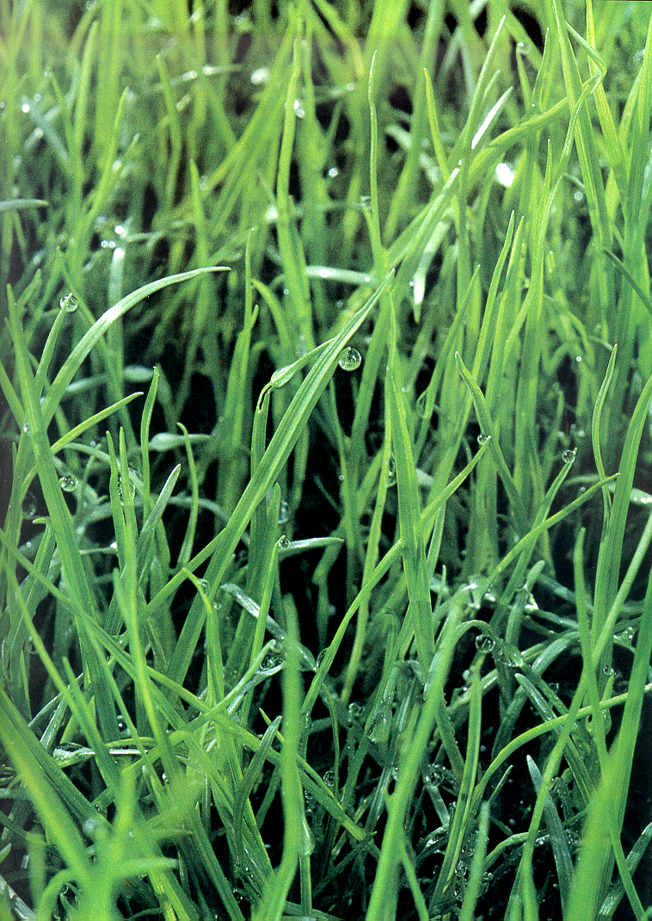
New Yards without existing landscapes
- Make sure the area is weed free. If weeds are present then remove them by hand or use an herbicide.
- If the soil is highly compacted and hard to dig in then it may be necessary to rototill in 3” of topsoil to loosen the soil and create a nice planting bed.
- Purchase the plugs and plant them in the soil using a metal dibble. Make sure the plug trays are well watered to begin with.
- Water in the plugs thoroughly the first time using hose end attachment fertilizers such as Miracle Grow.
- Water the plants daily for the first week or two with just enough water to keep the plugs moist and not soggy. The plugs must never dry to the point of wilt during this important establishment period.
- Once the plugs begin to grow ease off the water gradually to help the plugs establish and grow a strong root system.
- Fertilize monthly even in the hottest months using a liquid fertilizer.
- After the first year the lawn will be completely established and ready to withstand even the most rigorous drought situations.

When working with an established lawn it is very important that all the blue grass is removed completely. Any blue grass that is left alive will easily overtake and starve out the Legacy plugs. It may not be necessary to add top soil if the area is easy to work. If the soil seems compacted it may be necessary to rototill in 3” of top soil to have the plugs establish easily

- Either use a sod cutter to remove all the existing grass or spray the existing grass with a non- selective herbicide such as Round Up or Finale. Be sure to water your lawn area because a healthy lawn will better take up the herbicide and die faster than a sickly lawn. After spraying the lawn it may be necessary to do another couple of applications in the following weeks. If using a sod cutter water the area and wait a week to see if anything green comes up. If you get weeds either dig them out or use a non-selective herbicide to get rid of any of the weeds that are left. This may have to be repeated 1-2 times more to ensure that all the weeds are gone.
- Once the existing grass is completely removed or dead then follow the steps 3 – 8.

