

NURSERY, GARDEN CENTER, GREENHOUSE & PATIO
5150 Garrison St. Arvada, CO 80002 303-424-7979
www.echters.com

POINSETTIA CARE SHEET
Millions of poinsettias are purchased each year during the Christmas season by people who enjoy the color and warmth they provide to the home. Proper selection will help to insure a long lasting plant that you will enjoy throughout the holiday season.

Taking your Plant Home
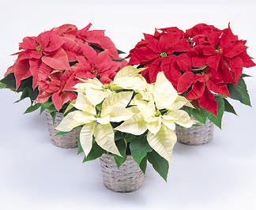

If you live in an area where freezing temperatures are common in December, you’ll have to provide some protection to your poinsettia when transporting it to your home. The store should provide a plastic sleeve or plastic bag that you can use to cover the plant. Even so, never expose the plant to cold temperatures for more than a few minutes; a chilled or frozen plant will begin to drop leaves very quickly. Once inside, remove the protective wrapping immediately and prepare to enjoy your new poinsettia.

Taking Care of your Poinsettia
With proper care your poinsettia will last through the holiday season and retain its bracts well into the new year. Pay close attention to the following care tips:

- Place in a room where there is bright indirect light for about 6 hours a day but not where the sun will shine directly on the plant.

- Avoid hot or cold drafts or excess heat from appliances, fireplaces, radiators, or ventilating ducts.

- Set the plant in or on a water-proof container to protect your furnishings.

- Water the plant thoroughly when the soil surface is dry to the touch. Remember to discard excess water from the saucer.

- To prolong the bright color of the bracts, temperatures should not exceed 72 degrees Fahrenheit during the day or 60 degrees Fahrenheit at night.

Reflowering your Poinsettia

If you have a gardener’s green thumb, you may want to try your hand at reflowering your poinsettia next year. If you follow these directions very carefully, it is possible to have your poinsettia in flower by Christmas.
Poinsettia Cycle:

- December: Full bloom. Water as needed.

- Late March to Early April: Color fades. Keep near a sunny window. Cut stems back to about 8”. Water as needed and fertilize with a well-balanced, all purpose fertilizer like Peter’s All-Purpose Plant Food. Around May you should see new growth.

- June 1st: Repot if necessary in a well-drained potting mix. You can put your plant outside if you would like as long as the night temperatures are consistently above 55F and it is protected from the hot sun.

- July-August: Pruning may be required to keep your plant compact and bushy. Do not prune after September 1st.

- Starting October 1st: Provide complete and continuous darkness for 12-14 hours night combined with 6-8 hours of bright light a day. During the night, stray light of any kind, street lights or household lamps, may delay or halt the re-flowering process.

- Remember: The key to success is to follow the strict light-dark requirements very carefully.

- Once your poinsettia is in the full color, stop fertilizing until it loses its color and the cycle starts again in March.

