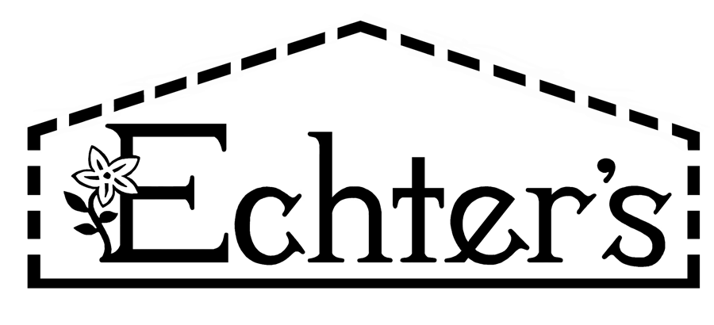
NURSERY, GARDEN CENTER, GREENHOUSE & PATIO
5150 Garrison St. Arvada, CO 80002 303-424-7979
www.echters.com

Project List for Potting a Bonsai

- 1. Container with drainage

- 2. Bonsai Potting Mix

- 3. Bonsai wire

- 4. Decorative Pebbles or Moss Spores

- 5. Pruning shears

- 6. Humidity tray

- 7. Peter’s All Purpose Plant Food

NURSERY, GARDEN CENTER, GREENHOUSE & PATIO
5150 Garrison St. Arvada, CO 80002 303-424-7979
www.echters.com

Project List for Potting a Bonsai

- 1. Container with drainage

- 2. Bonsai Potting Mix

- 3. Bonsai wire

- 4. Decorative Pebbles or Moss Spores

- 5. Pruning shears

- 6. Humidity tray

- 7. Peter’s All Purpose Plant Food

