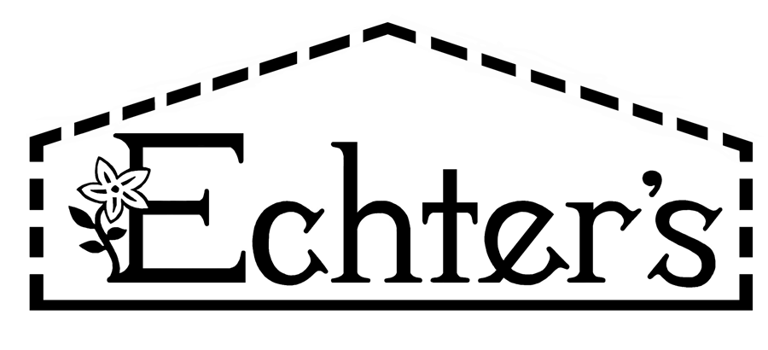
NURSERY, GARDEN CENTER, GREENHOUSE & PATIO
5150 Garrison St. Arvada, CO 80002 303-424-7979
www.echters.com

Project List for Planting a Cactus

- 1. Container with drainage holes

- 2. Drainage saucer

- 3. Cactus or Succulent Potting Mix

- 4. Cactus Juice Fertilizer

- 5. Leather gloves

- 6. Decorative Pebbles

NURSERY, GARDEN CENTER, GREENHOUSE & PATIO
5150 Garrison St. Arvada, CO 80002 303-424-7979
www.echters.com

Project List for Planting a Cactus

- 1. Container with drainage holes

- 2. Drainage saucer

- 3. Cactus or Succulent Potting Mix

- 4. Cactus Juice Fertilizer

- 5. Leather gloves

- 6. Decorative Pebbles

