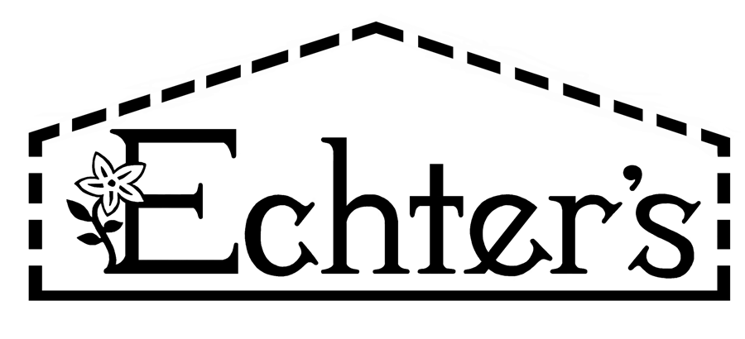
NURSERY, GARDEN CENTER, GREENHOUSE & PATIO
5150 Garrison St. Arvada, CO 80002 303-424-7979
www.echters.com

Project List for Prepping Your Pond for Fish

- 1. Aquasafe or Stress Coat

- 2. Aquazyme or Biofilter Booster

- 3. Pond Salt

- 4. Floating Food Sticks

- 5. pH Test Kit

- 6. Ammonia Test Kit

- 7.Fish

NURSERY, GARDEN CENTER, GREENHOUSE & PATIO
5150 Garrison St. Arvada, CO 80002 303-424-7979
www.echters.com

Project List for Prepping Your Pond for Fish

- 1. Aquasafe or Stress Coat

- 2. Aquazyme or Biofilter Booster

- 3. Pond Salt

- 4. Floating Food Sticks

- 5. pH Test Kit

- 6. Ammonia Test Kit

- 7. Fish

