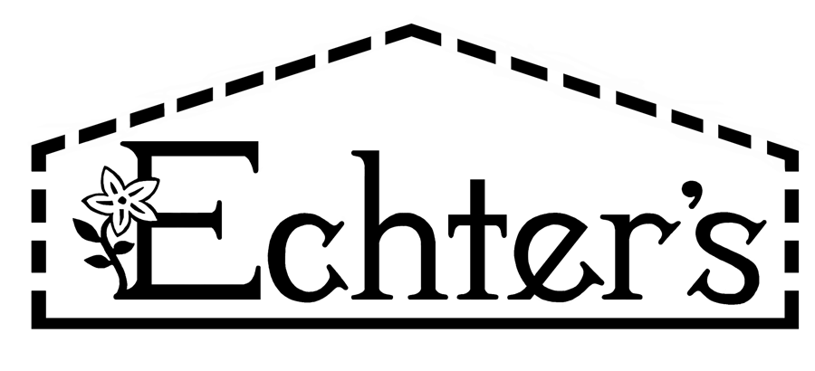
NURSERY, GARDEN CENTER, GREENHOUSE & PATIO
5150 Garrison St. Arvada, CO 80002 303-424-7979
www.echters.com

Project List for a Container Herb Garden

- 1.) Container with drainage holes

- 2.) Black Gold Organic Potting Media or Light Weight Potting Media

- 3.) Herb selections

- 4.) Gro-More Herb Fertilizer or Fish Emulsion

- 5.) Pruning shears

- 6.) Pot saucer

- 7.) Watering can

NURSERY, GARDEN CENTER, GREENHOUSE & PATIO
5150 Garrison St. Arvada, CO 80002 303-424-7979
www.echters.com

Project List for a Container Herb Garden

- 1.) Container with drainage holes.

- 2.) Black Gold Organic Potting Media or Light Weight Potting Media

- 3.) Herb selections

- 4.) Gro-More Herb Fertilizer or Fish Emulsion

- 5.) Pruning shears

- 6.) Pot saucer

- 7.) Watering can

