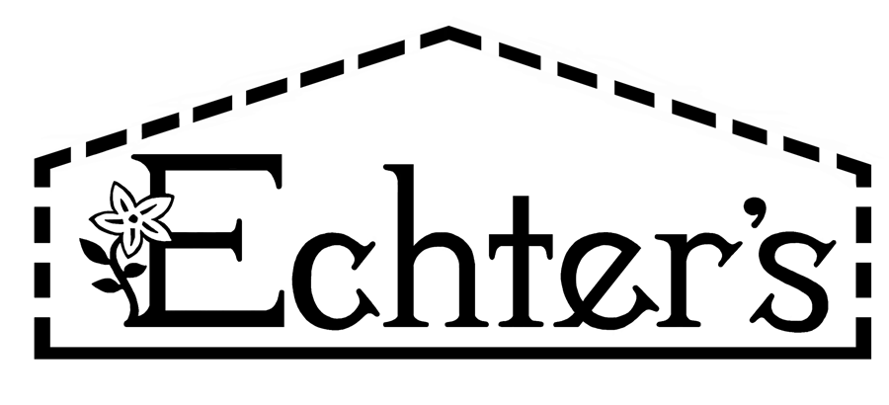
NURSERY, GARDEN CENTER, GREENHOUSE & PATIO
5150 Garrison St. Arvada, CO 80002 303-424-7979
www.echters.com

Project List for a Vegetable Garden

- 1.) Compost soil amendment

- 2.) Rental of rototiller

- 3.) Edging

- 4.) Mulch

- 5.) Plant supports, tomato cages, bean/pea trellis

- 6.) Fertilome Vegetable & Tomato Fertilizer

- 7.) Soaker hose or Drip Irrigation System

- 8.) Seeds or vegetable plants

- 9.) Shovel

- 10.) Hoe

- 11.) Pruners

- 12.) Gloves
NURSERY, GARDEN CENTER, GREENHOUSE & PATIO
5150 Garrison St. Arvada, CO 80002 303-424-7979
www.echters.com

Project List for a Vegetable Garden

- 1.) Compost soil amendment

- 2.) Rental of rototiller

- 3.) Edging

- 4.) Mulch

- 5.) Plant supports, tomato cages, bean/pea trellis

- 6.) Fertilome Vegetable & Tomato Fertilizer

- 7.) Soaker hose or Drip Irrigation System

- 8.) Seeds or vegetable plants

- 9.) Shovel

- 10.) Hoe

- 11.) Pruners

- 12.) Gloves

