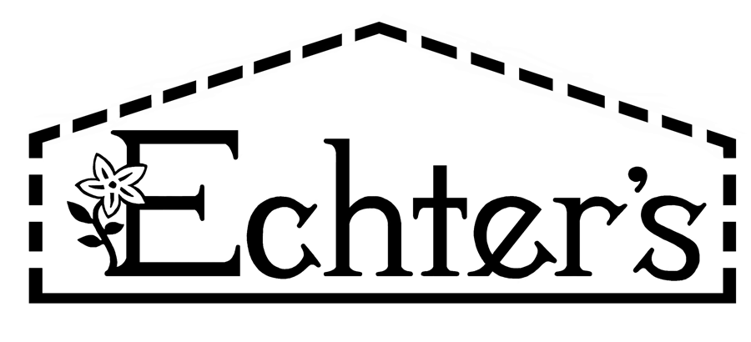
NURSERY, GARDEN CENTER, GREENHOUSE & PATIO
5150 Garrison St. Arvada, CO 80002 303-424-7979
www.echters.com

Project List for an Annual Container Garden

- 1.) Container with drainage holes

- 2.) Echter’s Hanging Basket & Planter Box Mix or suitable potting media

- 3.) Annual plant selections

- 4.) Fertilome Root Stimulator

- 5.) Peter’s Super Blossom Booster or suitable fertilizer

- 6.) Water wand with shut off valve

- 7.) Garden hose

- 8.) Watering can

- 9.) Pruning shears

- 10.) Pot feet or saucer

- 11.) Ceiling hooks

- 12.) Plant supports
NURSERY, GARDEN CENTER, GREENHOUSE & PATIO
5150 Garrison St. Arvada, CO 80002 303-424-7979
www.echters.com

Project List for an Annual Container Garden

- 1.) Container with drainage holes

- 2.) Echter’s Hanging Basket & Planter Box Mix or suitable potting media

- 3.) Annual plant selections

- 4.) Fertilome Root Stimulator

- 5.) Peter’s Super Blossom Booster or suitable fertilizer

- 6.) Water wand with shut off valve

- 7.) Garden hose

- 8.) Watering can

- 9.) Pruning shears

- 10.) Pot feet or saucer

- 11.) Ceiling hooks

- 12.) Plant supports

