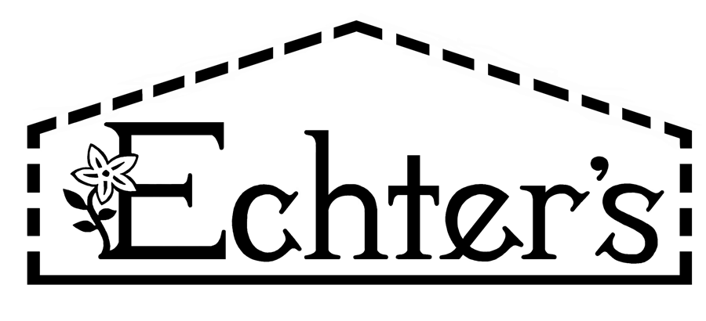
NURSERY, GARDEN CENTER, GREENHOUSE & PATIO
5150 Garrison St. Arvada, CO 80002 303-424-7979
www.echters.com

Project List for an Outdoor Herb Garden

- 1.) Compost soil amendment

- 2.) Edging

- 3.) Shovel

- 4.) Hoe

- 5.) Gloves

- 6.) Pruning shears

- 7.) Gro-More Herb Fertilizer or Fish Emulsion

- 8.) Pine Bark Mulch

- 9.) Plant supports

- 10.) Herb plant selections
NURSERY, GARDEN CENTER, GREENHOUSE & PATIO
5150 Garrison St. Arvada, CO 80002 303-424-7979
www.echters.com

Project List for an Outdoor Herb Garden

- 1.) Compost soil amendment

- 2.) Edging

- 3.) Shovel

- 4.) Hoe

- 5.) Gloves

- 6.) Pruning shears

- 7.) Gro-More Herb Fertilizer or Fish Emulsion

- 8.) Pine Bark Mulch

- 9.) Plant supports

- 10.) Herb plant selections

