GardenNotes #618

Pruning Evergreens
Most types of evergreen trees and shrubs need little to no pruning. Pruning may make the new growth bushier, but will not effectively control size. Select plants based on mature size to minimize pruning needs. If frequent pruning is necessary to keep plant growth in bounds and prevent interference with a walk, driveway or view, consider replacing the plant. Evergreen trees and shrubs are pruned according to species growth characteristics.

Pruning Evergreen Trees
On evergreen trees, avoid pruning the central leader (trunk). This results in the development of multiple leaders that are prone to wind and snow damage. If the central leader is killed back, select one branch to become the new leader and remove potential competing leaders.
Never allow co-dominant trunks (trunks of similar size) to develop. If multiple trunks begin to develop, select one and remove others.
For structural integrity on evergreen trees, all side branches should be less than half the diameter of the adjacent trunk (less than one-third is preferred). If the diameter of a side branch is too large, prune back part of the needled area to slow growth or remove the branch entirely back to the trunk.
Removing a large branch on evergreen trees
New needles will not grow from branches without needles. When a side branch is removed on an evergreen, cut back to the trunk just outside of the branch collar (the enlarged connecting area on the trunk around the limb).
Do not cut into or otherwise injure the branch collar. Do not make flush cuts. Remove the branch in a three cut method. [Figure 1]
Cut 1. Coming out 12-15 inches from the trunk, make an undercut a third to half way through the branch.
Cut 2. Moving a couple inches out past the 1st cut, make the second cut from the top, removing the branch. This double cut method prevents the weight of the branch from tearing the branch below the branch collar.
Cut 3. Make the third and final cut just outside the branch bark collar. Take extra caution to not cut into or otherwise injure the branch bark collar.
For additional details on pruning cuts, refer to CMG GardenNotes #613, Pruning Cuts.
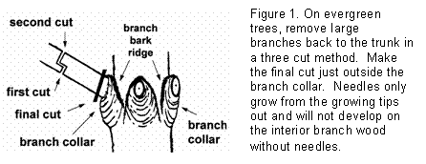

Pruning Spruce, Fir, and Douglas-Fir
Spruce, fir, and Douglas-fir generally need little to no pruning.
On young trees, pruning is useful in situations where bushier new growth is desired. Since these species produce some side buds, branch tips can be removed encouraging side bud growth. Prune late winter or early spring. [Figure 2]
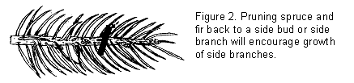
Spruce, fir and Douglas-fir that are over-growing their space are somewhat tolerant of being pruned back as long as it is not pruned back past the needles. However, with constant pruning, the branches may begin to show needle browning and dieback. In situations where the branch must be pruned back past the needles, remove it back to the trunk.
In landscape design small to mid-size evergreen trees, with their pyramidal form, generally look best with their lowest branches allowed to drape to ground level.
On large trees, primary growth occurs at the top with minimal growth at the lower levels. Due to slow growth, pruning of the lower branches may give a “pruned look” for a long time. On large trees, limb-up lower branches only if they are in the way.
Very slow growing species, like the Dwarf Alberta Spruce and Nest Spruce, are rather intolerant of pruning.

Pine
Pines generally need little to no pruning.
On young plants, if a more compact new growth is desired, “pinching” may be helpful. Using the fingers, snap off one-third of the new growing tips while in the “candle” stage (in the spring when young needles are in a tight cluster). Avoid using pruners or a knife, since it will cut the remaining needles, giving a brown tip appearance. [Figure 3]
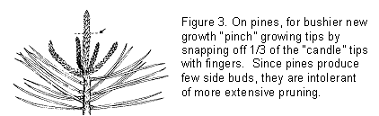
Since pines produce few side buds, they are intolerant of more extensive pruning. If the terminal bud on a branch is removed, growth on that shoot is stopped with additional growth occurring only from existing side branches. Do not shear pines.
Like other evergreen trees, small to mid-size pine trees look best (from the landscape design perspective) with their lowest branches allowed to drape down near ground level. When a lower branch has to be pruned back for space issues, remove it back to the trunk.

Junipers and Arborvitae
Junipers and arborvitae generally need little to no pruning.
They may be pruned anytime except during sub-zero weather. The best time is early spring prior to new growth.
The best pruning method is to cut individual branches back to an upward growing side branch. This method of pruning is time consuming, but keeps the plant looking young and natural. [Figure 4]
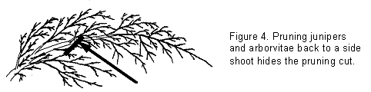
While shearing is quick and easy, it is not recommended, especially after mid-summer. Shearing creates a dense growth of foliage on the plant’s exterior. This in turn shades out the interior growth and the plant becomes a thin shell of foliage. Frequently sheared plants are more prone to show needle browning and dieback from winter cold and drying winds.
Any pruning that tapers in towards the bottom of the plant will lead to thinning of the lower branches due to shading. To keep the bottom full, the base of the shrub needs to be wider than the top portion.
It’s common to see junipers and arborvitae that have overgrown their space. Since new growth comes ONLY from the growing tips, branches cannot be pruned back into wood without needles. If the shrub is pruned back to bare wood, it will have a permanent bare spot.
For shrubs that are getting too large, it is better to prune them back as they begin to overgrow the site. Pruning back of severely overgrown shrubs generally gets into wood without needles. Consider replacing severely overgrown plants with smaller cultivars or other species.
Junipers and arborvitae growing in the shade are rather intolerant of pruning due to slow growth rates.

