

NURSERY, GARDEN CENTER, GREENHOUSE & PATIO
5150 Garrison St. Arvada, CO 80002 303-424-7979
www.echters.com

Raspberry Pruning

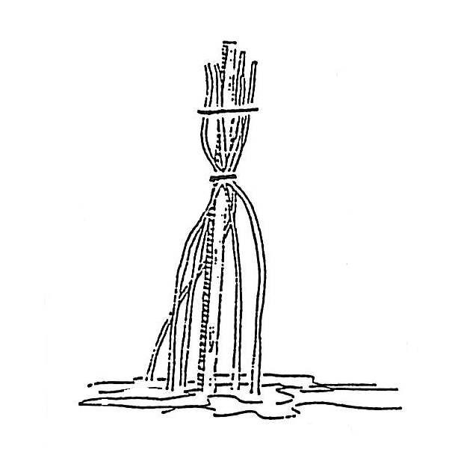
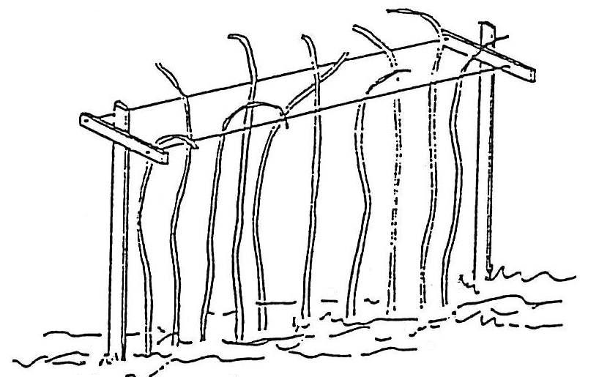

Single red raspberry plants can be trained to a single stake.
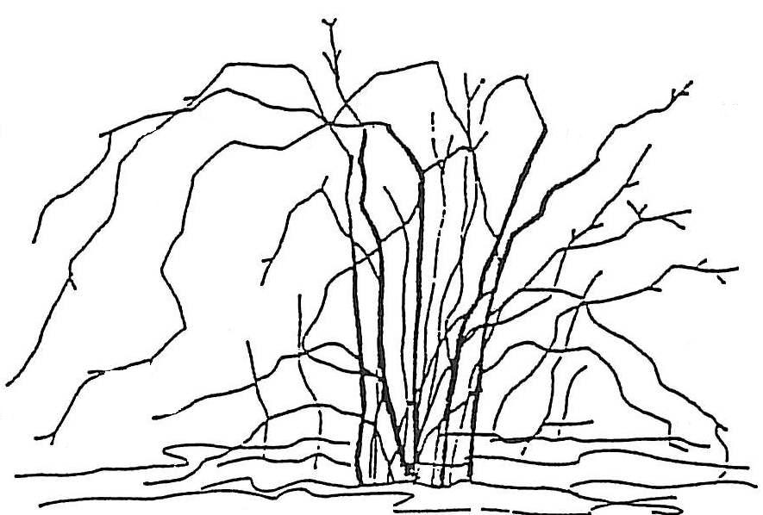
Red raspberries are frequently supported by two parallel, horizontal wires about 18” apart held by crossbars. Headed canes are pulled up between the wires. With a one-wire trellis, no crossbar is used and canes must be tied to wire.

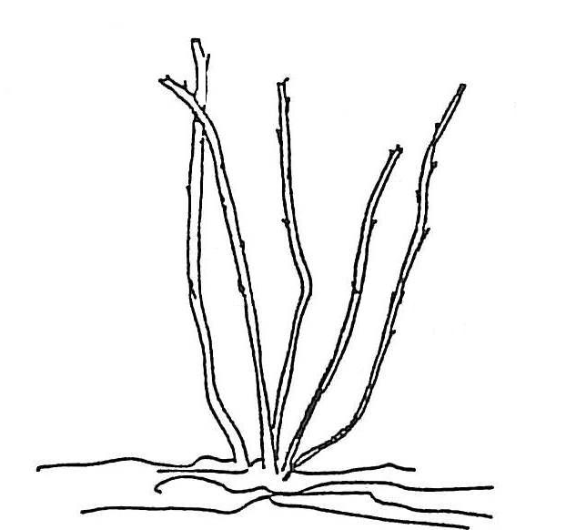

Black raspberries before and after pruning. Black and purple raspberries are not as vigorous as red raspberries and are usually pruned heavily and left freestanding.
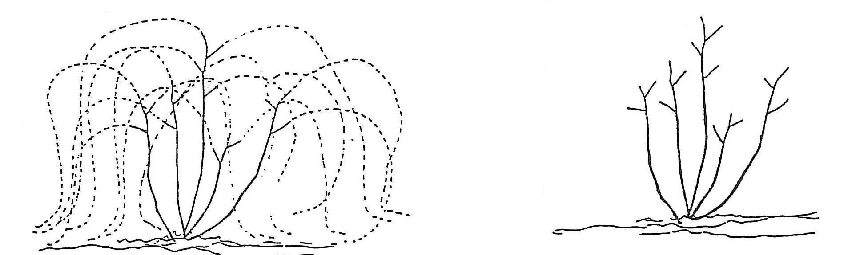

Red raspberries can be left freestanding by heading back below 4 ½ feet. Canes any higher may bend so fruit rubs against the ground.

