

NURSERY, GARDEN CENTER, GREENHOUSE & PATIO
5150 Garrison St. Arvada, CO 80002 303-424-7979
www.echters.com

REJUVENATING LILACS

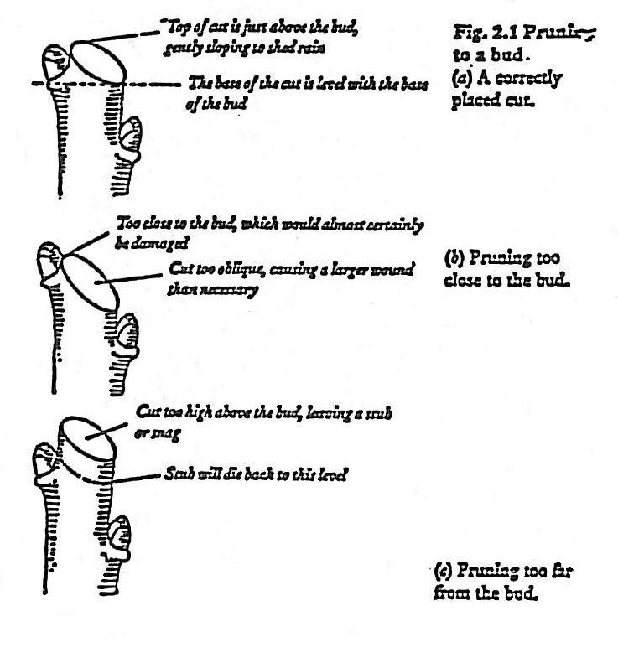
Just because a lilac has overgrown its space is not reason alone to remove it from the landscape. Lilacs and most other shrubs can benefit from pruning to reduce their size, and shape them to fit the space they have.

Heading back or shearing lilacs is the least effective
method of pruning-it leaves a thin, dense layer of leaves and reduces flowering. Taking a bit more time and cutting the individual branches back to side shoots, or even to the ground keeps a more natural and healthy shape, and improves flowering.

Lilacs respond well to rejuvenation pruning which is a fancy way of saying, “cutting back to the ground.”

New shoots will come up from the crown of the shrub, and within two to three years you should have a 3 to 5 foot, bushy shrub.

Lilacs can be pruned at any time of the year. Perhaps just after flowering is best for getting blooms next year, but pruning in late winter or early spring can allow you to see the shape of the shrub; use angled cuts.

Pruning back to a bud or shoot pointed to the inside will encourage more upright growth. Pruning to a bud or shoot pointed inside will encourage growth. Taking a few (up to 1/3) of the biggest and oldest canes back to the ground each year will maintain your lilac at a set size.

Rejuvenating an Aging Specimen

Sometimes an old shrub will become so overgrown, ungainly, and crowded with branches that you may be tempted to cut it down entirely. But a program of rejuvenation can usually give new life to old plants. This approach to pruning is less drastic than that recommended on the opposite page for cutting down overgrown plants.

In spring, before leaf growth starts, cut back all old branches to various heights, ranging from 2 to 6 feet. Remove excessively thin, wispy branches and all suckers (if any) from around the base. Apply a complete fertilizer, and mulch.

Some shrubs that may require this treatment

Bottlebrush Cotoneaster
Fothergilla Hibiscus syriacus
Lilac (syringa) Mock orange
Privet Viburnum
