

NURSERY, GARDEN CENTER, GREENHOUSE & PATIO
5150 Garrison St. Arvada, CO 80002 303-424-7979
www.echters.com

RESURRECTION PLANT

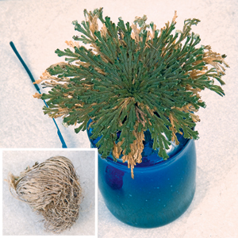
The amazing Resurrection Plant is so called because of its incredible ability to return to life when placed in a dish of water. From a tight dehydrated ball you will see a beautiful plant unfold. There is no limit to the amount of times the plant can be dried out and then “resurrected” again within a few hours.

TO START-- Place the fern in a large bowl of water at room temperature overnight. This will allow your plant to take up sufficient water to completely “resurrect”.

GROW-- Either in ordinary potting compost, or in a dish of plain water.

WATER -- Moist to dry. The appearance of the plant fluctuates with the amount of water present. It can survive drying out numerous times.

FERTILIZING – None required.

TEMPERATURE – Average household temperature, not below 50 degrees.

LIGHT -- Low light, partial shade to diffused sunlight.

PROPAGATION -- By cuttings taken in Spring, layering, or from spores.

