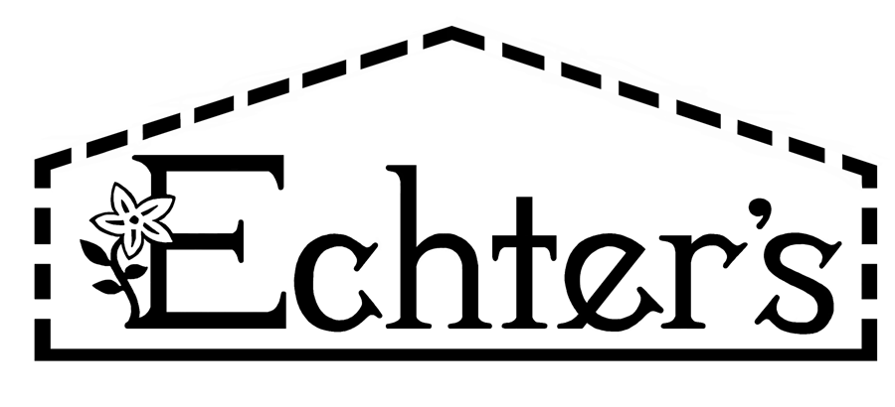

NURSERY, GARDEN CENTER, GREENHOUSE, & PATIO
5150 Garrison St. Arvada, CO 80002 303-424-7979
www.echters.com

SELECTING THE RIGHT PETUNIA

Petunias perform best in full sun and well-drained soil. They require regular applications of High Phosphorus Fertilizer to ensure flowering. Most cultivars need regular removal of spent blooms and pinching to promote good branching. Many have varied growth habits. It helps to know what look you hope to achieve when choosing your plants.

Groundcovers Mounding Hedgiflora Cascades
(low & prostrate) (for mass color, borders or mixed beds) (huge borders or mass planting) (hanging Baskets, Containers, walls)

Carpet Series (M) Tidal Wave Silver (G) Carpet Series (M)
Celebrity Series (M) Dreams Series (G) Tidal Wave Cherry (G) Celebrity Series (M)
Double Madness Series (DM) Double Wave Series (DM)
Madness Series (M)
Easy Wave Series (G) Prism Sunshine (G)
Priscilla (DG)
Wave Series (F) Supercascade Series (G)
Supertunia Series (G)
Hurrah Series (M) Surfinia Series (G)
Madness Series (M)
Picotee Series (G) Wave Series (M)

Purple Pirouette (DG) Double Cascade Series (DG)

Ultra Series (G)

(G) Grandiflora (F) Floribunda (M) Multiflora (ML Milliflora (DG) Double Grandiflora (DM) Double Multiflora

