
NURSERY, GARDEN CENTER, GREENHOUSE & PATIO
5150 Garrison St. Arvada, CO 80002 303-424-7979
www.echters.com

Snakes
Urban Wildlife Damage Control

Many people either do not know anything at all about Kansas snakes or have misconceptions about them. Most have heard so many stories about snakes that they fear all of them. This fear is unfounded! A person needs only to learn to identify the poisonous snakes that might be encountered in a given area and realize that all other snakes, lizards, frogs, toads, salamanders and turtles do not have a poisonous bite and need not be feared.

Conserving snakes is another aspect. Too many people kill snakes unnecessarily just because they are snakes. There is no more reason to kill a non-poisonous snake than a songbird. In many cases, snakes are of direct economic value.

In Kansas, snakes are protected by state law. You should obtain a collecting permit from the Kansas Department of Wildlife and Parks before attempting to catch and keep a snake.

Biology and Habits

Snakes retire for the winter in places where the temperature will not get below freezing – in rocky ledges, beneath the soil, below the roots of trees, or in protected places such as grain bins, cisterns, cellars and silos. With the warm days of spring, snakes emerge from their winter quarters and begin searching for food and mates. After mating, the male and female snakes separate, and each goes its own way to forage for food until the fall.

Urban Wildlife Damage Control

Bats, L-855 Opossums, L-860 Woodchucks, L-865
Birds, L-856 Raccoons, L-861 Woodpeckers, L-866
Blackbirds in Roosts, L-857 Skunks, L-862 Woodrats, L-867
Cottontail Rabbits, L-858 Tree Squirrels, L-863
Muskrats, L-859 X Snakes, L-864

Urban Wildlife Damage Control

Bats, L-855 Opossums, L-860 Woodchucks, L-865
Birds, L-856 Raccoons, L-861 Woodpeckers, L-866
Blackbirds in Roosts, L-857 Skunks, L-862 Woodrats, L-867
Cottontail Rabbits, L-858 Tree Squirrels, L-863
Muskrats, L-859 Snakes, L-864
Some snakes lay eggs while others produce live young. Kansas snakes are about evenly divided between the two. Kingsnakes, rat snakes, bullsnakes, racers and many smaller snakes lay eggs in early summer and deposit them in a spot suitable for hatching, generally, beneath a rock or in the soil.

When they hatch, the young fend for themselves. In Kansas, water snakes, garter snakes, poisonous snakes and some smaller snakes give birth to living young in late summer or early fall. Again, the young are on their own after birth. With cooler weather approaching, the snakes leave their summer feeding grounds and travel to places where they will become inactive for the winter.

Myths

There are probably more tall tales, about snakes than any other group of animals. There are stories about snakes putting their tails in their mouths and rolling downhill like a hoop, snakes that are capable of milking cows dry, snakes that fly into pieces when struck and later reassemble themselves and snakes that charm their prey. Some of these tales have to do with the extraordinary powers of snakes. For instance, there is the “blow viper”, whose breath is supposedly poisonous! Many people mistakenly think the poisonous “fang” of a snake is what they see flicking in and out of the snake’s mouth. In reality, it is the snake’s tongue, which is present in all snakes. The fangs are enlarged hollow teeth, in the front of the jaw, through which the poison passes during a bite. Here are four of the many popular myths about poisonous snakes:
- Rattlesnakes cannot cross a horsehair rope – they can!
- Cottonmouth water moccasins cannot bite under water – they can!
- Rattlesnakes always rattle before they strike – not always!
- The rattles present on the tail of a rattlesnake indicate the snake’s age – no, a new segment is added each time that the skin is shed, which may occur several times during a year.

Abundance

Nonpoisonous snakes far outnumber the poisonous kinds, both in number of species and individuals. In Kansas, there are five species of poisonous snakes and 33 species of nonpoisonous snakes. Snakes are more likely to be non-poisonous than poisonous. A good source of information about snakes in Kansas is Amphibians and Reptiles in Kansas by Joseph Collins, available from the Museum of Natural History, University of Kansas, Lawrence, Kansas 66045.

Benefits

Before deciding to kill a snake in your yard or garden, consider the many benefits. Snakes are one of nature’s most efficient mousetraps, killing and eating a variety of rodent pests. While snakes will not eliminate pests, they help keep their numbers in check. Some harmless snakes, such as king snakes, milksnakes, and black racers eat other snakes, including poisonous ones.

Snake venom has been used in developing a variety of human medicines. One type of high blood pressure medicine was developed using information based on chemical secrets contained in snake venom. Researchers are conducting studies using snake poisons in developing treatments for blood and heart problems. Snake venom is also being investigated for controlling some types of harmful bacteria.
Control Measures

The most effective and lasting method for getting rid of snakes is to make the area unattractive to them. This can be accomplished by removing hiding places such as old boards, debris, high grass or weeds. These measures will also reduce the food supply of insects and rodents and make the environment less attractive to snakes.

When snakes use houses or buildings for denning sites:
- Plug cracks and crevices and use screens at windows and doors.
- Inspect the masonry of foundations, fireplaces and chimneys and coat with cement, if necessary.
- Plug spaces around pipes passing through outside walls.
- Place galvanized screen over drains or ventilators. This also keeps out mice.
- Fill gaps between the outer walls and foundation.

At the same time snakes are being barred from the house, you should take steps to make the rest of the premises unattractive. Look at the surroundings as if you were a snake. Are there rodents or insects available for food? Are there places to rest, breed and carry out other necessary living functions? If you answered yes, plan to remove food and cover. Snakes eat rodents and insects so remove them and their water and shelter. Get rid of debris. Remove brush and leaf piles. Place staked material 12 or more inches above the ground or floor and away from walls. Keep shrubbery and other plants away from foundations and free of leaves and other debris. Keep space beneath structures and stacks clean and mow lawns closely. Fill unwanted depressions. Keep stream or pond banks clean and clipped; rocky banks are pleasing but they harbor snakes. If you prefer a naturalistic homestead, you must be willing to accept the presence of unwanted elements of natural communities, including snakes.

Only one chemical for repelling snakes is currently registrated in Kansas. It is available under the brand name, Dr. T’s Snake Away® and contains active ingredients Napthaulene and sulfur. It has not been tested by Kansas State University.

Exclusion

Snakes enter buildings in search of cool, damp, dark areas or places where rodents and insects abound. To prevent these unwanted guests from entering your home, check the foundation for cracks and openings ¼ inch or larger. Use mortar for poured concrete, concrete block or brick foundations. Use 1/8-inch hardware cloth or sheet metal to seal holes and cracks in wooden buildings. Seal cracks and openings around windows, doors,
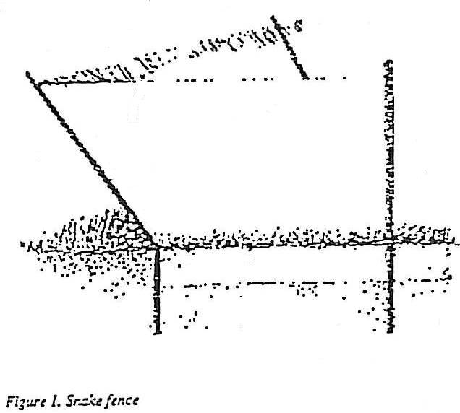
electrical pipes and wiring with caulk. If you have an open
septic or sump pump drain outside, cover the opening with
¼ inch hardware cloth. Be sure to check it periodically to
ensure that the wire does not interfere with drainage. If
you have young children and live in an area where
poisonous snakes are common, you may want to invest
in a snake-proof fence (Figure 1.) Snake-proof fences are
expensive to construct, so fencing an entire yard is not practical.
However, you can enclose a small area where young children play.
Removal from Inside Buildings

If a snake is found in a basement or under a dwelling, the snake should be identified, caught and released. Capture tongs can be used to safely pick snakes off the ground and remove them to an enclosure (tongs available from: Valentine, P.O. Box 53, Hinsdale, IL 60522).
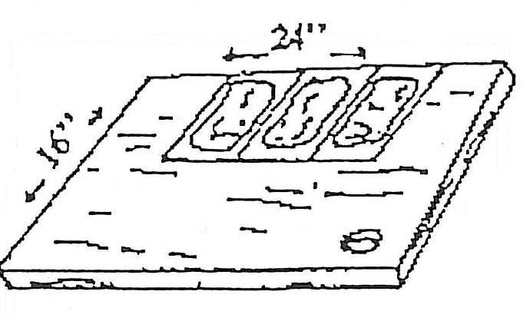
Glue boards also may be used to immobilize and remove the snake from the premises. To remove a snake with glue boards, attach three or four rat-sized glue boards to a small piece of plywood or staple four boards together. Place the glue boards along a wall or foundation. Snakes generally will travel along walls. When the snake moves across the glue boards, it will become firmly attached and can be removed. To release the snake from the glue boards, pour vegetable oil over the snake and boards, inactivating the glue.

You may purchase readymade glue boards, or make your own by applying glue to a piece of cardboard.

Occasionally homeowners will encounter a snake inside the home, usually in a basement or crawl space. Snakes are attracted to these areas by the warmth on cold days and the cool shade on hot days.

You can increase you chances of capturing a snake in the basement by placing rumpled, damp cloths covered with a dry cloth in areas where snakes have been. Then remove everything at once or capture snakes individually and remove them. If you are not afraid of snakes, the best way to remove them is to sweep them into a bucket or large garbage can with a broom.

NOTE: Homeowners should exercise extreme caution when moving in a crawl space, especially if venomous snakes have been in the area. A face bite could be very serious, and even a face-to-face encounter with a racer or rat snake can be an unpleasant experience.

How to Tell Kansas Poisonous Snakes from Nonpoisonous

The features given here apply only to Kansas snakes and may not be applicable elsewhere. Even in Kansas, there are some nonpoisonous snakes that exhibit either the tail or eye characteristics of poisonous snakes, but do not have the pit. These features can be seen only when the snake can be examined closely. Certainly, you should not pick up every snake to look for these characteristics!

WARNING: reflex action can cause an apparently “dead” snake to bite, so do not handle “dead” snakes with your hands; use a stick.

The best way to be able to identify a poisonous snake is to know all of the venomous snakes of your region by sight. Color and patterns are distinctive and easily learned.

Poisonous Snakes
- Pupil of eye elliptical, or cat-like.
- Pit between eye and nostril.
- Two enlarged teeth (fangs) in front of the upper jaw.
- Scales on underside of tail in a single row.
Non-poisonous Snakes
- Pupil of eye round (except for Texas Night Snake).
- No pit between eye and nostril.
- All teeth of upper jaw approximately same size.
- Scales on underside of tail normally in a double row; however, most scales on underside of tail on non-poisonous Texas long nose snake are in a single row.

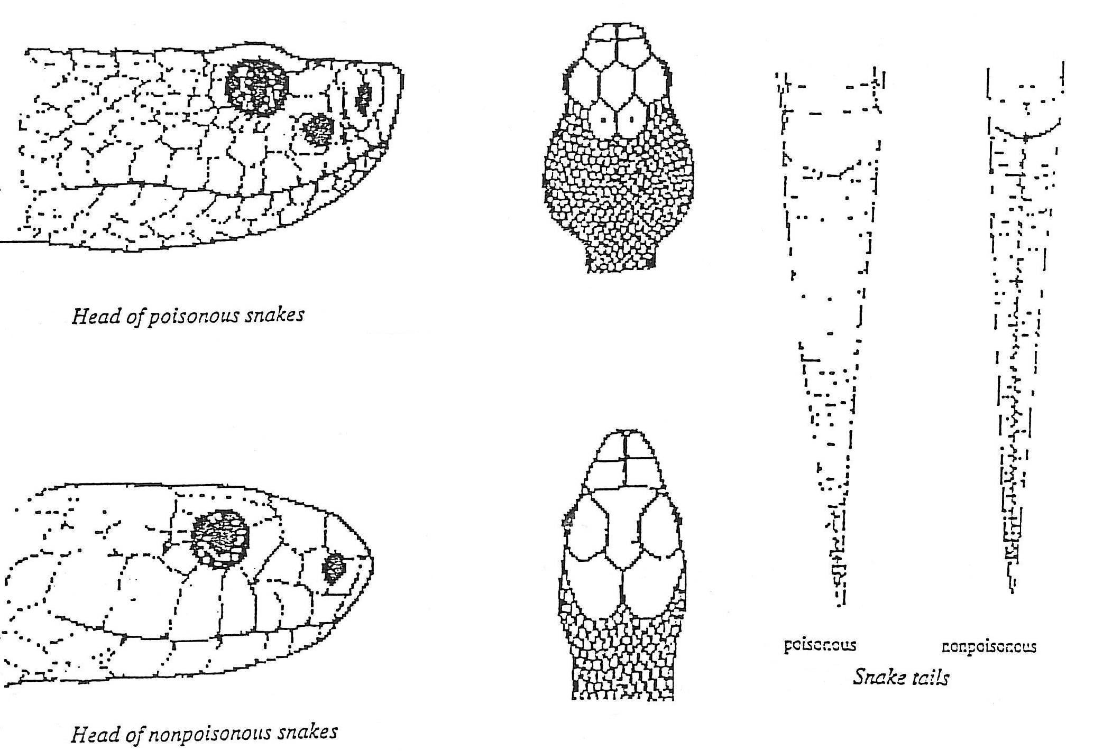
Snake Bites

Snakebites occur despite precautions. Most first aid texts do not encourage victims of snakebites to kill the snake. The victim may wind up being bitten a second time. Whether the snake was venomous or harmless is determined within a few minutes when the victim begins to experience pain and swelling at the bite. Also, in Kansas all snakebites are normally treated with Crotalid Polyvalent antivenin, applicable to all venomous species in the state, so identifying the snake is unnecessary.

In case of snake bite ---
- Stay calm – the snake may be nonpoisonous; if it is poisonous, excitement hurts, not helps.
- Get medical help quickly.
- Ask your doctor’s advice regarding snakebite – before it happens.
Poisonous Snakes in Kansas

Cottonmouth (Agkistrodon piscivorus) Length: 3 to 4 feet.

The poisonous water moccasin has rarely been captured in extreme southeast Kansas. The many general reports of water moccasins are cases of harmless water snakes common throughout most of Kansas being mistakenly identified.

Young cottonmouths are patterned like wide-banded copperheads, but are not as reddish. Cottonmouths are always found near water. When approached they often hold their ground and open their mouths wide, revealing the white lining, a habit that gives them their common name. This heavy-bodied snake is dangerously poisonous and, contrary to popular belief, can bite underwater.

While the copperhead is rather mild mannered, the cottonmouth has a vicious disposition. Although nocturnal, it likes to sunbathe, and frequently basks along shorelines, stretched out on low branches or on the bank. Where this snake occurs, it is usually common.

Generally, females bear eight or nine young in August or September, although the number of young may range from 5 to 15. Like the copperhead, the young have a yellow tail tip.

Copperhead (Agkistrodon contorix) Length: usually 2 to 3 feet.

Common where it occurs, the copperhead is probably the most abundant poisonous snake in eastern Kansas. It is most frequently found near rock ledges in oak-hickory-walnut woods, but individuals may be found in almost any habitat during summer months. Although generally nocturnal during most of its active season, its habit of lying in the open during the daytime among dried leaves in patches of sunlight and shadow causes the pattern to blend perfectly with the background. Any hiker walking through this habitat should be alert.

Because of the rather small size of this snake and low toxicity of its venom, the bite is normally not fatal to adults. Elderly persons, those in poor health, or small children are in more danger from copperhead’s bites.

A subspecies of the copperhead occurs along the southern border of Kansas. In this form, the cross bands are wider along the mid-line than those of the more northern variety.

Young copperheads have a sulfur-yellow tail. This color is lost as the snake matures. It is thought that this contrasting tail color is used as a lure to bring prey within striking distance of the small snake. The young are born in August or September. There may be from 2 to 10 in a litter.

Massasauga (Sistrurus cantenatus) Length: 24 to 27 inches.

This snake belongs to a group of small rattlesnakes called “pygmy” rattlesnakes, which are differentiated from the larger rattlesnakes by the large scales on top of the head, like the copperhead and nonpoisonous snakes. The massasauga occurs in open fields and rocky outcroppings. It is particularly common in the Flint Hills and at Cheyenne Bottoms. This is the “prairie rattler” of eastern Kansas, often found under hay bales in fields.

Its food consists primarily of small rodents. The small size and usually docile disposition of this snake tend to place it upon the non-dangerous list, but its venom is extremely toxic and ANY bite from a massasauga is dangerous. When aroused, these small snakes strike with a fury not seen in larger snakes. The rattling of this small snake is hardly louder that the buzz of a grasshopper.

The name “massasauga” is an Indian term, meaning “swamp-dweller”, a habitat preference which is evidenced more in the states to the east and northeast of Kansas.

Two subspecies occur in Kansas. In the eastern part of the state is the form characterized by a dark belly; the lighter bellied form occurs in southwestern Kansas.

Females bear 8 or 9 young, usually in August or September.

Timber Rattlesnake (Crotalus horidus) Length: 3 to 4 feet. Occasionally longer.

The timber rattlesnake occurs only in eastern Kansas and is only common at scattered locations. It prefers the deciduous forest where limestone rock outcrops as ledges, but may wander into cultivated fields and open areas during late spring and summer.

The food consists primarily of small rodents and young rabbits. Ordinarily, it is a mild-mannered snake and seeks to escape direct contact with humans, but its size and habit of living close to human habitations makes this rattlesnake dangerous. Ground color may vary from a light gray to yellow, with the black chevron-shaped blotches of the back uniting with lateral blotches to form cross bands. The tail is characteristically velvet black in adults but banded in young.

During late spring and summer the timber rattlesnake is quite often encountered crossing roads, where its large size and slow movement often make it a victim of modern transportation.

The timber rattler has a habit of spending daylight time just beneath the edge of overhanging rocks and logs. A hiker should always look beneath rocks of this sort before using them as a resting place.

Prairie Rattlesnake (Crotalus virdis) Length: 3 to 4 feet.

This rattlesnake is common in western Kansas, where it frequents rocky open regions, grassy prairies and agricultural areas. Its habit of denning in large groups is well known. Several hundred have been found in a single winter den.

The food of the prairie rattlesnake is warm-blooded, mostly rodents and small rabbits. It appears to be active in the daytime, whereas the other poisonous snakes are mainly nocturnal. The ground color varies from light gray to green, and the pattern of dorsal blotches with alternating rows of lateral blotches may cause it to be confused with the smaller massasauga, but the scales on top of the head are all small on the prairie rattlesnake, whereas large plates are present of the massasauga.

Young are born in late summer or early fall. A litter usually consists of nine to twelve, but litters with as few as five and as many as seventeen have been recorded.

A female prairie rattlesnake gives birth to a litter of young every other year. These young are generally about 12 inches long.

This snake has a wide range over the western United States, where it is probably the most common rattlesnake. It is frequently found in prairie dog villages. Rattlers use prairie dog burrows for shelter and the young rodents.

For sources of supplies and references or educational assistance contact:
Animal Damage Control
Rm. 128 Call Hall,
Kansas State University
Manhattan, KS
66506-1600
(913) 532-5654

Also watch for the publication, Sources of Wildlife Damage Control Supplies, Rural and Urban, to be published later.

Brand names appearing in this publication are for project identification. No endorsement is intended or implied, nor is any criticism of similar products not mentioned.

