

NURSERY, GARDEN CENTER, GREENHOUSE, & PATIO
5150 Garrison St. Arvada, CO 80002 303-424-7979
www.echters.com

Snapdragons
(Antirrhinum Majus)

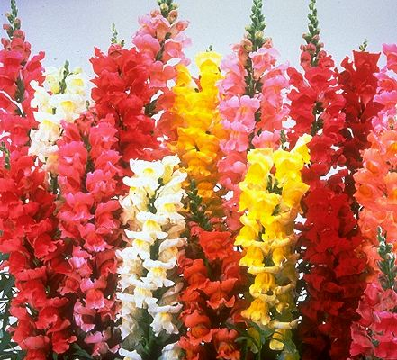
Snapdragons are fantastic in form and color, and come in a wide range of heights. They are vigorous and bloom abundantly. This is an old-fashioned favorite of children, who enjoy pinching the individual blooms to watch the dragon’s mouth open and close. This popular plant is really a perennial, but is usually grown as a half-hardy annual in colder climates. In my garden, I cut them down in the fall and hope for the best. In the spring, I am often rewarded with the return of many plants.

These plants bloom heavily in early summer and, if faded, cut off spikes and they will continue blooming all summer long, but with smaller spikes of blooms. For your bouquet, cut snapdragons when the individual flowers on the lower third of the stem are open. The other florets will continue to open if given light.

Of the tall varieties, the ‘Rockets’ and double flowering ‘Madame Butterfly’ hybrids produce strong plants and magnificent flowers. Among the intermediates, the ‘Tahiti’ series produces a good color range, and the ‘Liberty’ series has shapely spikes of brightly colored flowers. The dwarf varieties ‘Little Darling’ and ‘Floral Carpet’ are vigorous and colorful.

Snapdragons do not like heavy soils, as their roots are fine. If planting in clay, add lots of compost or peat moss. They perform best in cool weather in sun or light shade.
Set out transplants in early spring along with other cool growing annuals like pansies. Pinch tips at this time to promote bushy, more compact plants. To keep plants in vigorous growth, water when soil is moderately dry and feed regularly.

Rust can be a problem for snapdragons. It is best to grow resistant varieties. Rust is easily recognized by the brown dust on the undersides of leaves and stems. Avoiding overhead watering, giving plants' plenty of room for good air circulation and discarding infected debris in fall will help control rust.

For gardeners of all ages, Snapdragons are beautiful and easy to grow. A wide range of heights, color and flower form makes them a wonderful addition to beds or in container gardens.

