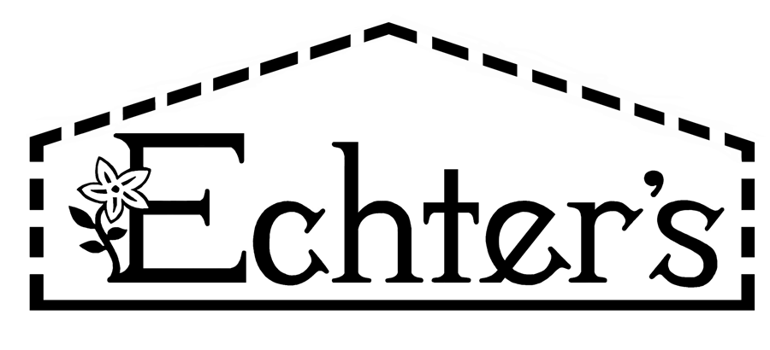

NURSERY, GARDEN CENTER, GREENHOUSE & PATIO
5150 Garrison St. Arvada, CO 80002 303-424-7979
www.echters.com

Soils & Barks

Peat Moss:

Biologically sterile, peat moss reduces alkalinity (lowers ph), aids in retaining soil moisture, increases aeration aiding in root development, keeps nutrients from leaching away and acts as a buffer against toxic substances.

When rototilled or forked into the soil, peat moss loosens heavy soils and binds light or sandy soil.

Not to be used straight for planters, but can be mixed with planter box mix.

Manures:

Although manures add some fertilizer value, it is not a reliable source. Most of our manures are mixed with compost and/or sphagnum peat moss. Manures are soil amendments by rototilling into your gardens or in preparing soil for grass seed or sod.

Manures can also be used as a top dressing on established lawns after aerating.

Manures are not for planters or container gardening.

Compost:

Nature’s Yield Compost is the best soil conditioner for rototilling into vegetable, flower gardens and for mixing with your soil when planting trees, shrubs, vines and perennials. Compost improves water retention and aids in root development and penetration. Not to be used in container gardening.

Clay Buster is Nature’s Yield Compost with pumice added for further aeration in heavy soils.

Permagreen Mushroom Compost is a blend of manures and forest products and can be used to loosen clay soils for planting in the garden. Do not use in containers

Black Gold Garden Compost is made up of 35% compost, forest humus and peat moss and should be incorporated into the garden. Do not use in containers

Ecoscraps Compost is a blend of over 26 different composted fruits and vegetables. It is an all-natural and organic mix that is rich in trace minerals and elements. Ideal for amending any garden, flower bed or lawns soil.

Top Soils:

Mixture of one or all of the following: top soil, forest products, humus and compost. Good for mixing into the gardens, for top dressing and filling in low spots in the lawns or gardens.

Mulches:

Pep & Mini Bark is very fine ground bark good for mulching around perennials, annuals, trees, shrubs and rose bushes. Will decompose some and can be turned into the soil at the end of the season.

Bark and Cedar Bark Mulch can be used as a decorative addition around perennials, roses, trees and shrubs. Must be removed to improve soil. Mulches help keep a constant temperature in the soil as well as helping the soil retain moisture.

Container Soil Mixes:

Fafard mixes are blended for container planting and do not need to be blended with any other soils. Some mixes have fertilizer added to feed plants for part of the season.

Nature Yield Outdoor Planter Mix is already blended for planting in containers and should not be mixed with other soils. It is blended for good drainage in planters and pots.

Garden Soil Mixes:

The following blends are all for gardens or raised beds and should be worked into the native soil at a rate of ½ and ½. These can also be used in the planting of trees, shrubs, roses and perennials.

Gro-Rich Garden Soil Happy Frog Soil Conditioner
Black Gold Planting Mix Pro-Mix Outdoor Planting Mix
Miracle-Gro Organic Garden Soil Permagreen Planter’s Mix

