

NURSERY, GARDEN CENTER, GREENHOUSE & PATIO
5150 Garrison St. Arvada, CO 80002 303-424-7979
www.echters.com

Nerine Bowdenii
(Surprise Lily)
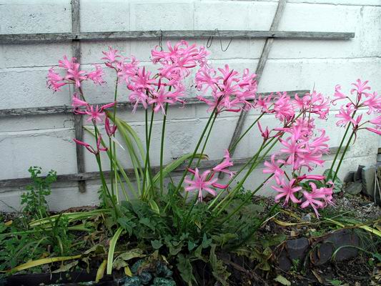
Beautiful pink orchid like flowers of 8-12 grow on a 2-foot strong stem. The leaves will grow and disappear before the flower “surprisingly” comes up in late September. Nerine makes a wonderful long lasting cut flower also.

Location: Part shade or filtered sun.

Plant: In well drained soil 6” deep and 12” apart.

Flowering Time: Late September or early October.

After Care: For best results, lift and store bulbs over the winter. If the area is protected a heavy mulch will protect the bulb.

Sparaxis
(Harlequin Flower)

Beautiful splashes of color come from the tiniest corm. Flowers are 2” across on slender stems of 8-12”. Sparaxis looks best when planted in groups.
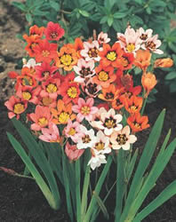
Location: Sunny area.

Plant: Corms should be planted 2” deep and 2” apart in well-drained soil. Incorporate peat moss and compost into the soil.

Flowering Time: July and August.

After Care: Dig up corms in late summer and store in vermiculite in a cool place (40-50 degrees F).

