

NURSERY, GARDEN CENTER, GREENHOUSE, & PATIO
5150 Garrison St. Arvada, CO 80002 303-424-7979
http://www.echters.com/

Sunny Annual Container Care

Sunny annuals usually require 6-8 hours of sunlight per day. They thrive in the sunlight, and are slow to grow in filtered light. They are well suited to decks, southern exposures, and are usually drought tolerant. Many will do well in western sun as well.
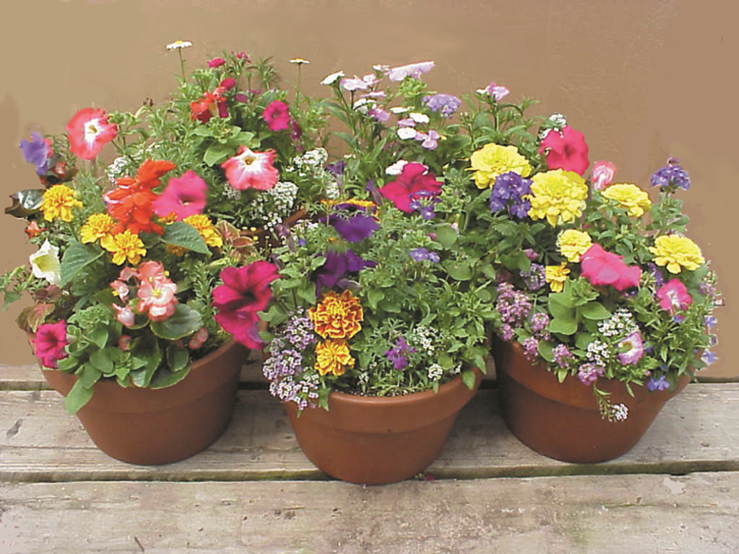
Because these planters are used in sunny, hot areas, the moisture level of the soil should be checked regularly. Many will withstand running fairly dry, but growth and blooming may be affected if the soil is repeatedly allowed to reach this state. At the same time, over-watering should be avoided. The best method of checking the moisture level in the post is to simply place your finger in the soil and feel it. If your soil is moist, there is no need to water. If the soil is only slightly moist or mostly dry a few inches deep, consider watering. Take into consideration the temperature expected that day, overcast skies, and if the soil in the mid- to lower-range of the pot is moist. An established plant will probably be fine without watering. If the temperatures are expected to be hot and the soil at the mid-level of the pot is only slightly moist, the plant may become stressed in the midday heat and sun. The container will also a bearing on the moisture needs of plants. If the container is clay, water will be drawn to the clay and evaporate through it, so the soil will dry out faster. If the container is plastic or ceramic, the soil will retain moisture longer. Hanging baskets, although usually in plastic, will dry out in sun and heat more easily due to ample air circulation. This does not necessarily mean it will need daily watering. Again, it is best to feel the soil.

Avoid overhead watering: this will deteriorate blooms more rapidly.

Fertilize your container plantings regularly. This will stimulate growth of the plant and roots, promoting more blooms. Fertilome Flower Grower or Peter’s Super Blossom Booster are both bloom promoting fertilizers.

Pinch plants regularly to encourage branching, particularly during early growth. Better branching will provide sturdy plants, and the more branching, the more blooms result. Pinching will also reduce leggy growth, leaving you with lush, full plants. When pinching, remove the selected growth just above a leaf. This is the point at which the plant will branch.

Remove spent blossoms just as they begin to deteriorate. Plants spend a great deal of energy producing blooms. The less energy spent on dying blooms, the more energy the plant can dedicate to producing new flowers. By pinching and removal of blooms, the planter will maintain its shape, rewarding the gardener with beauty throughout the season.

As there are many different combinations of planters offered, please contact an annuals salesperson if you have any questions about the needs of your container garden.

About bougainvillea: avoid transplanting. These plants shock easily when their roots are disturbed. Prune the vining branches to encourage further growth and blooming. Fertilize with a high phosphorus plant food. These plants may shock somewhat, dropping blooms and foliage initially. They will quickly recover and begin blooming again. Allow soil to moderately dry–avoid over-watering. This plant may be wintered indoors. For more detailed information, you may pick-up a care sheet specific to this plant from the Customer Service counter or an annuals salesperson.

About petunias: pinch regularly during early growth to encourage branching and to avoid leggy limbs with few flowers. Remove spent blooms regularly. Allow soil to dry moderately between waterings. Avoid over watering and fertilize regularly.

About verbena: this one loves the sun and heat. Allow soil to dry somewhat between waterings. Feed regularly. Remove spent blooms frequently.

As always, please contact Echter’s with any questions you may have about your plants. We are happy to help you select the plants perfect for your conditions.

