

NURSERY, GARDEN CENTER, GREENHOUSE & PATIO
5150 Garrison St. Arvada, CO 80002 303-424-7979
www.echters.com

Terrariums

How they work –
Plants will grow indefinitely in sealed glass containers because of the greenhouse effect: Water evaporates from the soil and provides humidity; droplets then condense on the side of the glass and roll down the sides into the potting mix, bringing moisture to the roots.

Container choices –
A fishbowl, large food canister, glass jug, vase, brandy snifter, or pitcher will work fine as long as it is transparent and waterproof.

What to Grow?
The best plants for terrariums are those that like low light and high humidity. Select either one showy specimen large enough to fill the container or mix plants with different shapes and textures. Use dwarf or slow-growing plants that have the same cultural requirements (growing conditions).

Getting Started –
First, wash the container with a solution of 10% household bleach and water to prevent the growth of molds and fungi. Rinse well and dry thoroughly.

The Layered Look –
Build up the planting medium in layers. Start with some fine gravel or sand mixed with a little horticultural charcoal. Top with a Echter’s Indoor Potting mix – about ½ inch for small terrariums and 2-3 inches for larger containers.
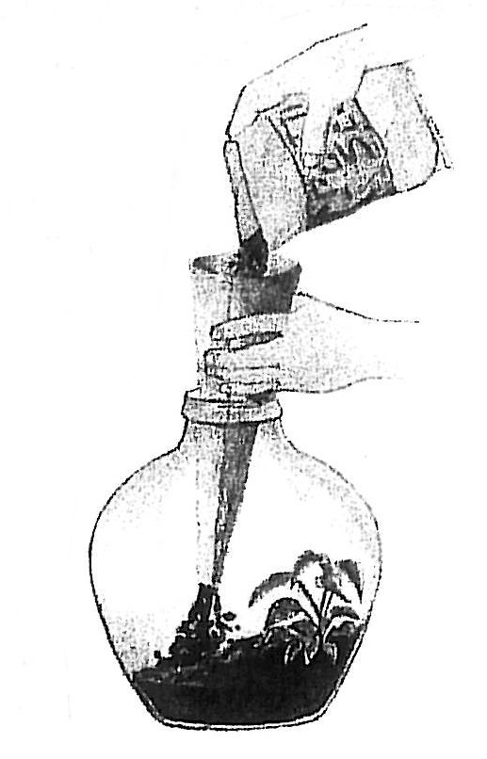
A paper funnel makes it easy to fill a small necked vessel without getting the sides dirty. Simply roll up butcher paper or sheets of newspaper into a funnel and pour potting mix and drainage materials through.

(over)
Three Planting Steps –
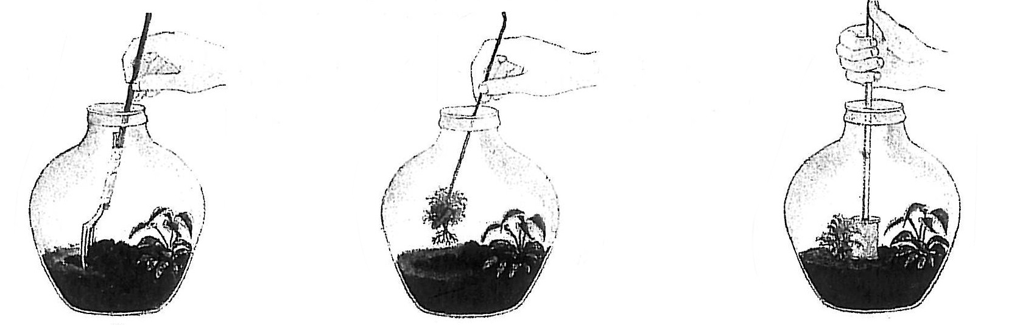
A few simple household utensils are all you need to place plants in a narrow-necked bottle or jug. Use a fork taped to a stick to make the planting holes. Use tweezers, tongs, or a wire with a loop at one end to set in the plants. For tamping down the potting mix, you can use a cork or empty thread spool wedged firmly on a chopstick.

Covering Your Container is optional.

Proper Placement –
Put the container in indirect sunlight or place it under a fluorescent light for 12 hours daily. Rotate container regularly to keep plants growing evenly.

When to Water –
It is natural for tiny water droplets to form on the inside of the glass. When the droplets disappear, additional water may be needed. Add a tablespoon at a time until the potting mix is evenly moistened.

Too Much Condensation?
If the glass becomes so foggy that it obscures your plants, the soil is too wet. Wipe out the excess moisture and give the soil time to dry a bit. Wait until soil turns a lighter color before watering again.

Hold the Food –
Don’t fertilize your garden plants the first year. Thereafter, feed very lightly, diluting an all–purpose houseplant fertilizer (20-20-20) to about 1/8 strength. If plants grow too large, prune them, transfer them to a larger vessel, or replace them.

Terrarium Plants –
If you’re growing woodland plants, keep your terrarium “cool” by placing it where the temperature is not more than 70°F. For a “warm” terrarium, suitable for tropical specimens, keep the surrounding temperature at about 75° F.

Terrarium Plants
Anthurium | Moneywort
Baby’s-tears | Mosses
Begonias | Norfolk Pine
Caladium | Parlor Palm
Creeping Fig | Peperomias
Croton | Prayer Plant
Cypress | Sedums
Ferns | Violets
Fittonia | Wintergreen

