

NURSERY, GARDEN CENTER, GREENHOUSE & PATIO
5150 Garrison St. Arvada, CO 80002 303-424-7979
www.echters.com

TILLANDSIA / AIR PLANTS

These unique plants are found naturally in Central and South America.

Tillandsia typically grow without soil and are found clinging to rocks and trees, but they are not parasites. There are some types that live in the soil.

ALL TILLANDSIAS BLOOM They have bright long-lasting flowers. Some plants will change colors completely and the blooming process may last 2 to 6 months. After the plants bloom they produce offshoots called pups. Pups are completely independent plants and can be removed from the parent plant when the pup reaches half the size of the parent plant.

CARE: Tillandsias store moisture, air, and nutrients through the gray fuzzy cells on the plants. Simply mist your plant two to three times per week. Do not allow water to accumulate in the base of the plant. Give your plant plenty of light and air.

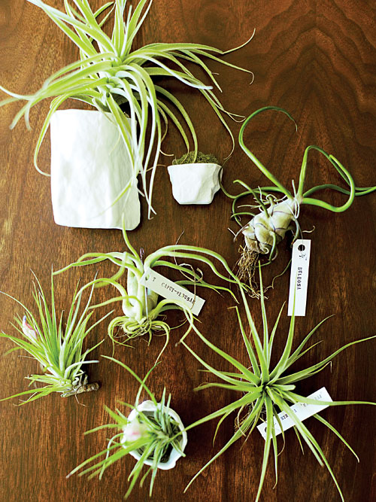
Have fun and enjoy your plant as it grows and multiplies.

