

NURSERY, GARDEN CENTER, GREENHOUSE & PATIO
5150 Garrison St. Arvada, CO 80002 303-424-7979
www.echters.com

Tips for Pruning

Very little to no pruning is recommended for the first two years. Your plants need to establish a greater root zone, and the more top growth, the more the plant can photosynthesize.

Look for these three (3) things when pruning: Dead branches, broken branches and branches that cross over and/or touch (Crossovers).

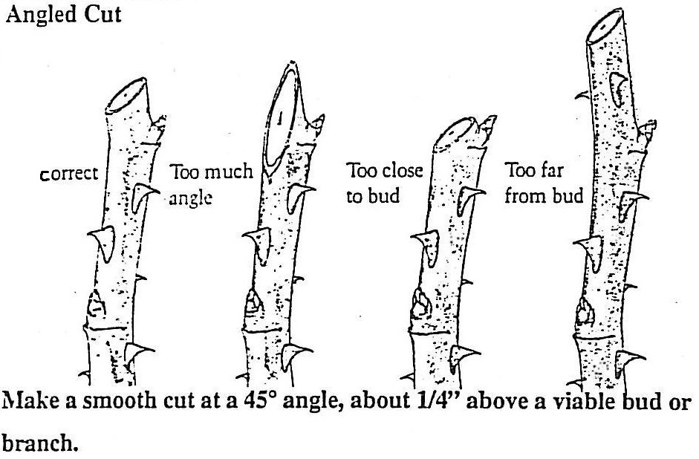
- Dead Branches: These are the most important to remove. They do the plant no good, and removal of these branches helps to open the plant to the sun for more growth. Always cut back to the main trunk or a viable side branch.

- Broken Branches: These may appear as a result of moving and planting accidents. The key is to make a clean, angled cut below the damaged area. Cut back to a bud, a side branch or the main trunk.

- Crossovers: Crossing branches are normal, but those that touch each other can wound each other, or even grow together. It is advisable to remove the less viable branch with an angled cut well below the touching point. Look for a bud, side branch or twig pointing away from the crossing branch.

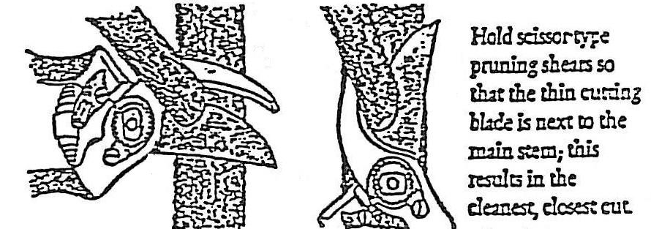
Holding your pruners:

** Echter’s does not recommend pruning paints or sealants. Please ask if you have any questions **

What and When to Prune

Winter Pruning for Trees:

- Ash – Little pruning needed.
- Aspen – Early. Will bleed if pruned in spring. Remove older trees to let younger mature healthy.
- Catalpa – Train when young. Remove suckers.
- Cottonwood – Train when young. Remove suckers.
- Elms – Remove suckers. Little pruning needed.
- Fruits and Crabapple – Late winter. Disinfect between each cut.
- Golden Raintree – Little pruning needed.
- Hawthorns – Late winter. Remove water sprouts and suckers. Little pruning needed. Disinfect after each cut
- Honeylocust – Little pruning needed.
- Kentucky Coffeetree – Little pruning needed.
- Linden – Little pruning needed. Maintain central leader.
- Mountain Ash – Disinfect between each cut. Maintain central leader. Watch for weak branch angles.
- Oak – Little pruning needed.
- Redbud – Little pruning needed.
- Willow – Remove dead wood as needed. Watch for weak branch angles.

Winter Pruning For Shrubs:

- Cotoneaster – Disinfect between each cut. Little pruning needed.
- Dogwood – Renewal pruning, removing full stems down to the base of the plant.
- Hydrangea macrophylla – Take down to 3-4 inches.

Early Spring Pruning For Shrubs:

- Barberry – Renewal. Little pruning needed.
- Butterfly Bush – Take down to 18” to 24”.
- Burning Bush – Little pruning needed.
- Caryopteris – Take down to 10” to 12”.
- Forsythia – Renewal.
- Honeysuckle – Renewal.
- Hydrangea paniculata – Renewal. Little pruning needed.
- Ornamental Grasses – Take down to 3” to 6”.
- Potentilla – Rejuvenation.
- Rose of Sharon – Little pruning needed.
- Smokebush – Little pruning needed. Remove winterkill only.
- Spirea – Rejuvenation.
- Sumac – Rejuvenation.

Spring Pruning – Roses:

- Remove dead, diseased and suckers to maintain an open shape on all types. Prune to an outside bud.
- Antique and Old Garden roses – Renewal.
- Miniatures – Little pruning is needed.
- Hybrid Tea, Grandiflora, Floribunda and Shrub – Rejuvenation.

Late Spring – Trees and Shrubs:

- Golden Raintree – Little pruning needed.
- Ornamental Pears – Disinfect after each cut. Little pruning needed.
- Prunus – Early spring. Little pruning needed.
- Serviceberry – Little pruning needed. Disinfect after each cut.
- Beautybush – Rejuvenation.
- Broom – Little pruning is needed.
- Lilac – Rejuvenation.
- Mockorange – Rejuvenation.
- Prunus – Rejuvenation.
- Quince – Rejuvenation.
- Spirea – Rejuvenation.
- Viburnum – Little pruning needed.
- Weigela – Little pruning needed.

Summer – Trees and Shrubs:

- Birches – Little pruning is needed.
- Purple Robe Locust – Remove weak crotches and suckers. Maintain a central leader.
- Maple – Prune when leafed out, if needed.
- Russian Olive – Remove weak crotches. Maintain a central leader.
- Peashrub – Rejuvenation.
- Privet – Rejuvenation.

Evergreens

- Arborvitae – Little pruning is needed.
- Cypress – Late spring. Little pruning is needed.
- Fir – Early spring. Little pruning is needed.
- Juniper – Late winter to shape. Shear anytime.
- Pine – Early spring. Pinch candles.
- Spruce – Early spring. Pinch candles.
- Boxwood – Late winter.
- Daphne – After flowering. Little pruning needed.
- Euonymus – Early spring to shape.
- Holly – Late winter to shape.
- Oregon Grape Holly – After flowering
- Pyracantha – Late spring. Disinfect after each cut.
- Yew – Late winter.

