NURSERY, GARDEN CENTER, GREENHOUSE & PATIO

5150 Garrison St. Arvada, CO 80002 303-424-7979
www.echters.com

TREE PEONY

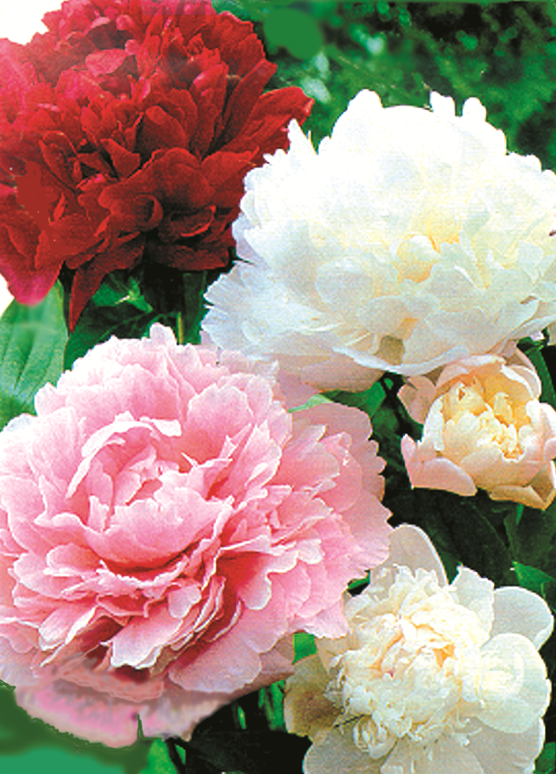

Tree peonies are one of the most glamorous of all plants for the garden. Not really trees at all, they are a deciduous shrub with woody stems. The site chosen for a tree peony is very important since it must be sheltered from icy winds and grows best with morning sun only.

Prepare the soil to 18" deep with generous amounts of spaghnum peat moss and about 1/2 lb. bone meal or Super Phosphate added in. A full grown tree peony can spread to five feet so give it a good wide planting site.

Plant very deep. Tree peonies are grafted onto the roots of traditional herbaceous peonies and the graft union should be visible as a bulge on the lower stem. The graft union should be covered with 6" of soil (this may be deeper than it is planted in the pot). The roots are brittle so handle carefully. Cover roots and water well. Plants should not be allowed to dry out, but ensure excellent drainage at all times. Cover woody stems for the winter with evergreen branches or other light, porous mulch. Cut out visibly dead branches before the pant begins to leaf out in the spring. spring only when buds begin to swell. Never cut off woody stems.

Tree peonies bloom in late May/early June, and should be given a good feed each year in May. Use Jack’s Classic All-Purpose Fertilizer, and be sure to remove spent flowers promptly.

Plants are unlikely to bloom in the first year after transplant, and it can take a few years for them to settle in and flower. Once the plant is established, it will produce dozens of gorgeous silken flowers each year.

