

NURSERY, GARDEN CENTER, GREENHOUSE & PATIO
5150 Garrison St. Arvada, CO 80002 303-424-7979
www.echters.com

U/V UNITS

What is a U/V Unit?

A U/V unit is a filter accessory that safely allows water to come into close proximity to a light tube producing large amounts of ultra violet light. This ensures that the passing water receives a strong dose of ultra-violet (U/V) light, not too dissimilar to the part of the sun’s light that causes sunburn.

What Does a Pond U/V Unit Do?

Used correctly, a pond U/V unit will effectively control the green algae that cause pea soup conditions. It will also help to reduce the haziness caused by very fine particles suspended in the water.

If I Have A Cloudy, Green Pond, Do I Need a U/V Unit?

Not necessarily. You need only consider a U/V unit if you already have a biological pond filter that is not coping with green water conditions. If you do not already have a biological pond filter then we would recommend this first. If you do have a biological filter that does not seem to be working, then consider the following:
- Is the filter big enough for the pond and the number of fish?
- Is the filter flow at the recommended rate?
- Has the filter been given sufficient time to settle and mature?
- Has the filter been disturbed by switching off the pump; over-cleaning the media; using strong pond medications or chlorinated water straight from the tap?
- Are there poor water conditions, e.g. very high or low pH; excessive amounts of debris on the pool base; large amounts of soil washing into the water?
- Have you raised the pump off the pool base? It should be at least 15cm (6” up).

In many cases, adjustment of an existing filter may be sufficient. However, if the filter tends to clog frequently, and especially if there are build-ups of toxic fish waste in the water (e.g. nitrite/NO₂), you would be wise to spend some money on upgrading to a larger filter rather than purchasing a U/V Unit.

My Pond Filter Keeps the Water Healthy, But It is Not Always as Clear as I Would Like. Will A U/V Unit Help?
In these cases a U/V Unit will almost certainly help. These units are especially useful in boosting the performance of an existing biological filter. They may also allow a more compact biological filter to be used, for a given size pond.

How Does A U/V Unit Work?
The Ultra-violet light has two major effects. It damages algae cells, preventing them from multiplying normally. It also alters the proteins on the surfaces of cells and fine debris particles, encouraging them to flocculate into larger particles. The filter then removes these larger particles more easily. To be fully effective, a U/V Unit should be used in conjunction with a biological filter.

What Are The Limitations Of A U/V Unit?
These units cannot control existing growths of blanketweed (thread algae), and have very little effect on blanket weed growth. They have no purifying effect on the biological waste from fish. So although they may give clear water conditions, these might not be healthy for the fish if waste is not being broken down by biological filtration.

The U/V Unit requires an electrical supply, and the tubes need replacement annually. The tubes are more expensive than ordinary fluorescent lamps. The unit must be positioned correctly to reach maximum efficiency, to allow for maintenance, and to ensure electrical safety.

How Do I Fit A U/V Unit To My Pond?

Units can be filled on the inlet or outlet of biological filters or run in a separate loop (see diagrams). There are different advantages to each option and we will be happy to advise you on the best option for your particular circumstances. Wherever you position the unit, follow the manufacturer’s recommendations for safety and protect the unit from water logging. Most units are weatherproof, not waterproof. The unit may need to be removed or drained down in the winter to protect it from frost. For permanent fixing, sufficient room should be left to allow removal and changing of the tube and components. The flow rate through the unit is not critical, but manufacturer’s guidelines should be followed.

U/V fitted on the Filter Outflow
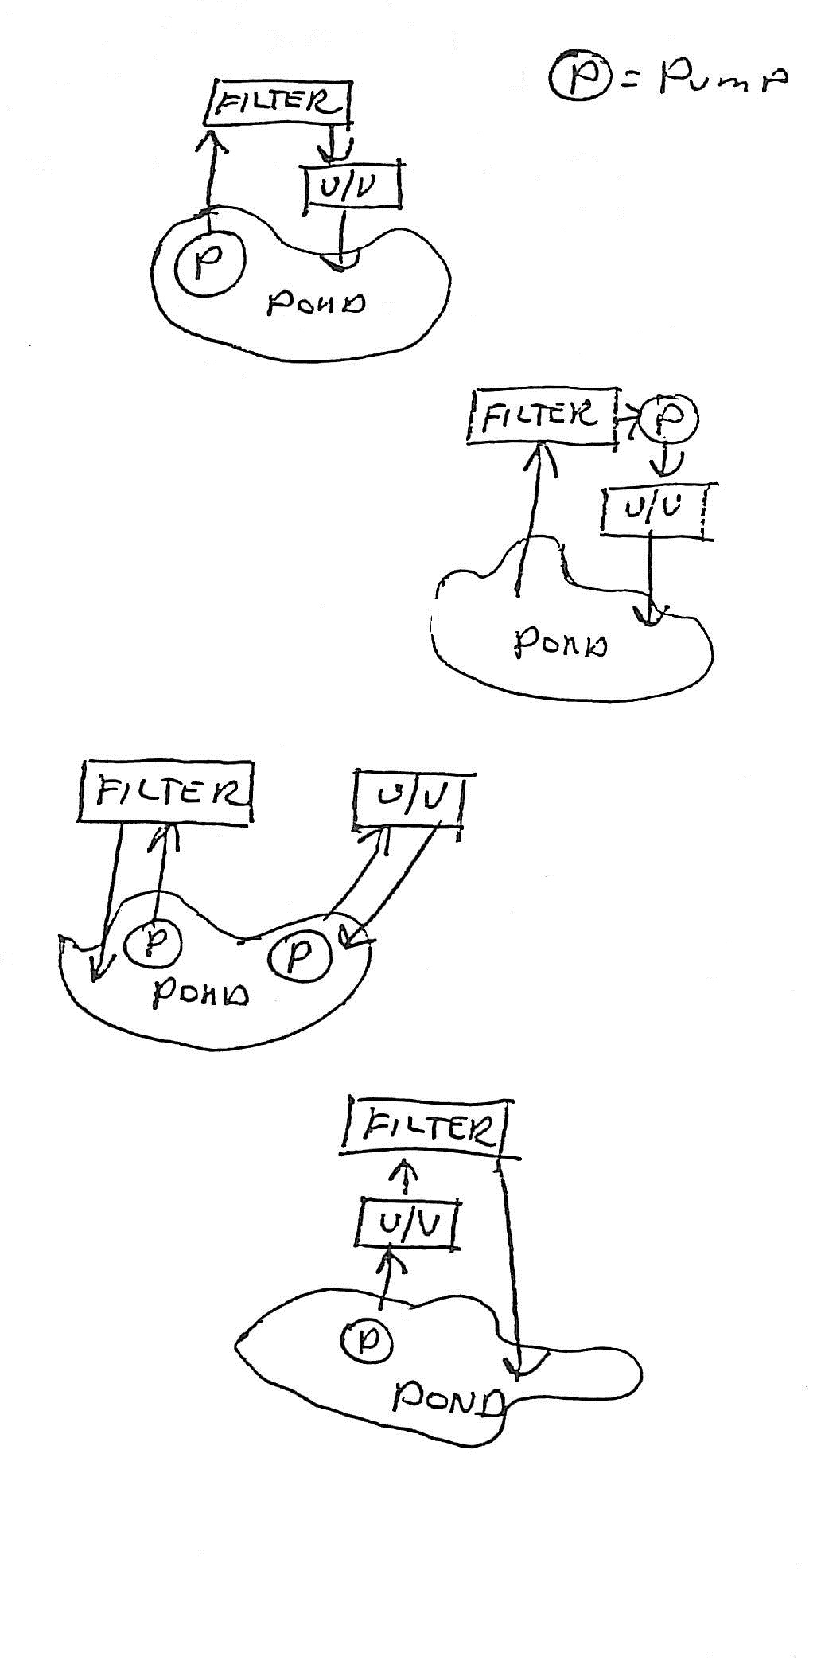
Advantages: Cleaner water passes through the U/V unit, increasing efficiency and reducing the need for cleaning the unit.
Disadvantages: More complex to plumb in. Because the U/V can restrict water flow, an extra pipe may be required to carry excess water from the filter to the pond.

Gravity Fed Filter - U/V Fitted To Pumped Return Flow.
Advantages: Easy to plumb in. Cleaner water passes through the U/V unit, increasing efficiency and reducing the need for cleaning the unit.
Disadvantages: Gravity fed filters can be more expensive and are generally better suited to large ponds. Otherwise few disadvantages.

U/V in a Separate Loop to Pond Filter
Advantages: Easy to plumb in. The U/V can be operated separately from the filter and turned on and off as required. It can also be removed for maintenance/wintering.
Disadvantages: Solids in the water reduce the U/V efficiency and dirt can quickly build up in the unit. A pump pre-filter foam can help to an extent. A separate pump my be required.

U/V Fitted Before the Filter Inlet
Advantages: Easy to plumb in. In some cases the U/V unit can be positioned on the filter lid.
Disadvantages: Solids in the water reduce the U/V efficiency and dirt can quickly build up in the unit. A pump pre-filter foam can help to an extent. To allow pond organisms to effectively colonize the filter, the U/V unit should not be turned on whilst the filter is maturing (the first 6 weeks).

Capacity

A 4-watt unit suits ponds up to 360 gallons capacity.
An 8-watt unit suits ponds up to 600 gallons capacity.
A 15-watt unit suits ponds up to 1440gallons capacity.
A 25-watt unit suits ponds up to 2160 gallons capacity.
A 30-watt unit suits ponds up to 3600 gallons capacity.

In conditions where the pond is very lightly stocked and in a shady position, the U/V units will often cope with double the capacities noted above. For larger ponds, units can be joined together or special multi-units can be ordered. An appropriately sized unit will normally clear green water in between 5 and 20 days.

Maintenance

In general, the unit can be turned on when the water becomes hazy and turned off a few weeks after it clears. Left on permanently, the units will reduce levels of waterborne bacteria and fungi, but cannot achieve the effects of U/V “sterilizer” units, which are of a different design and dose water at a much higher level. In very green water, dirty water, or hard water, algae cells and sediment can coat the quartz sleeve within a few weeks and cleaning will be required. In ideal conditions, the quartz sleeve need only be cleaned when replacing the tube. The tube output falls with time, and we recommend replacing the tube once a year in the spring. Follow the manufacturer’s instructions carefully - the quartz sleeve is both fragile and expensive. Regularly check electrical connections to ensure that they are in a safe condition. Turn off the U/V when using pond medications. Protect units from frost or drain them in the winter.

