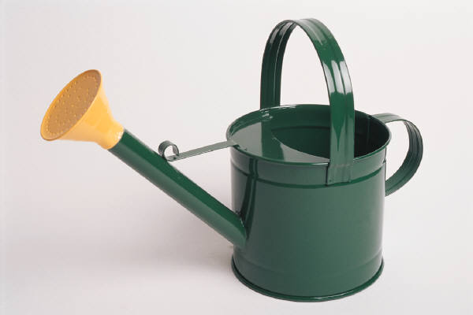

**Watering Houseplants**

Most plants prefer their soil to be moderately moist. Allowing the soil to dry about ¼ its depth is a good approximation.

Plants that prefer soil to become moderately dry before watering usually prefer to dry about ⅓ to ½ the soil depth.

Whenever water is applied, the soil should be saturated until some water begins to empty into a drainage tray. If the soil isn’t evenly saturated, dry root pockets will develop, resulting in damage.

Avoid allow any plant pot to sit in water. This leads to root rot, resulting in plant loss.

Take the mystery out of watering by using an inexpensive water meter, available near the registers.