
NURSERY, GARDEN CENTER, GREENHOUSE & PATIO
5150 Garrison St. Arvada, CO 80002 303-424-7979
www.echters.com

Western Pride Dryland Pasture Mix

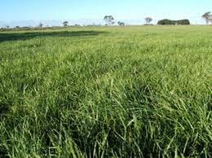
20% DH 3 Annual Ryegrass

15% Rush Intermediate Wheatgrass

19.75 % Enhanced Tall Fescue

19.75 % Gain Festulolium

17.75% Smooth Bromegrass

7.75% Bounty Orchardgrass

Seeding Rate: 20-25 pounds per acre (1 lb per 1000 square feet)

Western Pride Dryland Pasture Mix contains grasses suitable for use in dryland conditions. This mix is made with both sod-forming and bunch-type perennial cool-season grasses. Western Pride Dryland Pasture Mix is heat and cold tolerant, with a deep probing root system. Western Pride Dryland Pasture Mix is very palatable, especially to cattle and sheep and will supply good nutrition to livestock and wildlife. This mix is also used for soil stabilization and naturalization of roadsides and hills and over-seeding meadows and wildlife areas. This durable mixture will adapt to average soils with average fertility but will respond favorably to biannual fertilization. Clovers may be added to this mix at the rate of 2 pounds per acre to be planted. During years of drought, it is important that livestock not overgraze Western Pride Dryland Pasture Mix.

