

NURSERY, GARDEN CENTER, GREENHOUSE & PATIO
5150 Garrison St. Arvada, CO 80002 303-424-7979
www.echters.com

Windowsill Herb Gardens

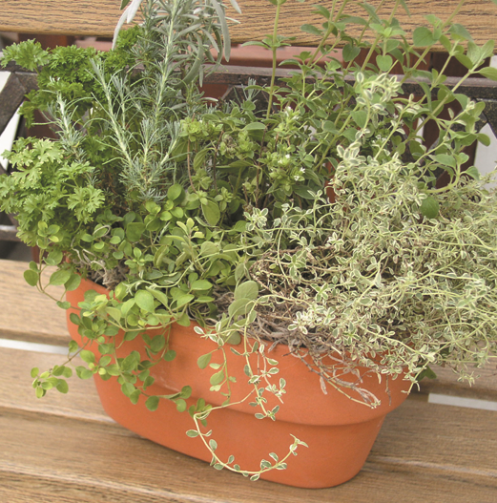
- Choose a sunny location where your plants will receive 6-8 hours of sunlight on their foliage per day.

- Choose pots with drainage and use lightweight peat base soil mixes for planting.

- If you plant herbs together in pots, choose plants that have similar water requirements.

- When planting, cover drainage hole with a potshard to prevent soil loss when watering. Place some soil mix in bottom of pot. Loosen roots of pot bound plants and place in pot. Cover with soil, being certain not to plant deeper than soil level of original pot. Water thoroughly and place in windowsill. Plants should have some spacing and pots should only be as close as leaf edge to leaf edge for optimum growth.

- Water according to plant type needs. If you are growing rosemary, sage, or lavender avoid getting water on the foliage to prevent possible powdery mildew. It is also best to water in morning hours to help prevent fungal disease problems.

- Humidity is beneficial, but misting should be avoided. Extra humidity can be accomplished by clustering several pots of plants together or by using a pebble tray.

- Fertilizing is important. Plants should be fertilized every other watering to promote best growth. Special herb fertilizers are available if desired.

- Should insect problems develop, use only treatments identified as useful against the known pest and are safe for use on edible plants. These include insecticidal soap, pyrethrin based sprays, lightweight horticultural oils, pepper sprays and physical removal of pest. Always read labels completely and follow directions exactly when applying any pesticides. Some formulas are suitable only on certain plants or against certain pests and if used inappropriately may damage plants or result in inability to use plants.

Harvesting and Storing Your Herbs

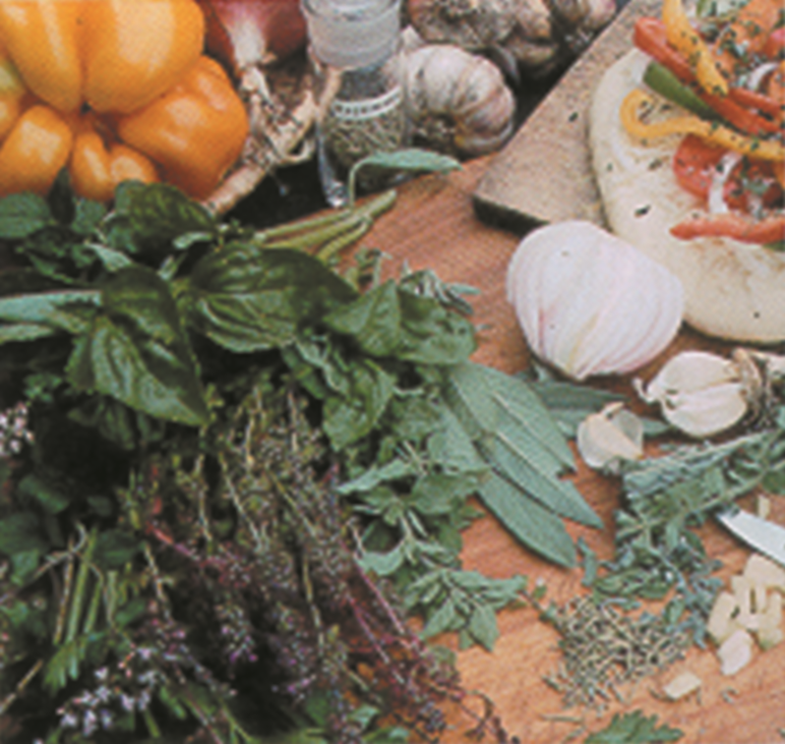
Fresh leaves can be picked for immediate use at any time during growth season. If you are planning to preserve your herbs for later use, lay flat in a basket or wooden box. Do not put them in a sack or bag, as they can bruise and start to sweat. Collect leaves in the morning hours. Foliage is most tender and sweet when the plants are young, preceding flowering. Label as you clean your plants dry to avoid confusion. Once dried many herbs look alike. Let leaves dry well in the sun or a slow oven. Microwave drying can be used but care should be taken as it may only take seconds. Most foliage herbs can also be double bagged fresh and frozen for up to 6 months without flavor loss. If storing in jars, a sachet of powdered milk will help absorb any moisture, if your herbs dry unevenly. Store your airtight jars of dried herbs in a dark cupboard, as light can break down stored oils.

Do not crush herbs until ready to use. This will help them retain their fresh taste longer.

Harvesting whole plants should be done just prior to flowering. If only green parts are wanted, cut back annual herbs to 3” above soil level and take no more than 1/3 of perennial herbs. If only leaves are desired for storing, remove from stems following drying and keep leaves whole to retain fresh scent and flavor.

Flowers are best collected in dry weather, just as they are fully open. If flowers are allowed to stay on plants for longer periods, shattering will result. Once picked, keep flowers in open containers to avoid bruising and sweating until dry. They are best stored flat to avoid damaging before use. Remove dried petals of larger flowers like calendula and keep small flowers like lavender and chamomile intact.

To harvest seeds or fruit, wait until fully ripe, but before seeds are dispersed. They should be buff, brown or black with no green remaining. Shake small seeds into paper bags or remove flower heads and hang over trays to collect seeds. Keep seeds separate, label and date. Seed air dry quickly, within 2 weeks in warm, dry environments. Berries and hips will take longer and require turning for even drying.

Harvesting roots is best done in the fall when plants are entering dormancy. This is also when essential compounds are greatly concentrated in roots. Dig up, avoiding damaging or cutting roots. Separate the desired amount and replant remainder. Most roots can be scrubbed clean, but valerian should not be scrubbed, as essential compounds are in surface cells. To dry roots, bake in a 140-degree oven, turning regularly. Roots of marshmallow and licorice should be peeled before drying. Once dry, store in airtight containers. Discard if they become soft.

A fun way to store finely chopped herbs is to place 1 tablespoon of herb in each cell of an ice cube tray. Fill with water and freeze. Use in specialty drinks for unique presentation and flavor or add to soups and stews, depending on what you stored in the trays.

Basic Culinary Herbs

Angelica

Strong, clean flavor. Give character for fruit salads and in syrup over ice creams.

Basil

Indispensable for Mediterranean dishes. Sweet, clove-like spiciness. Add to fresh tomatoes with salad oil, or add to tomato dishes. Basil adds interest to rice salads and combines well with zucchini, summer squash, beans and mushrooms. Stands up to garlic and together makes classic pesto sauce. Also adds flavor to poultry, pork and fish. Pungency increases with cooking. Fresh leaves keep their flavor well when preserved in oil or vinegar.

Bay Laurel

Better dried than fresh. Use with parsley and thyme to make a bouquet garni. Add a leaf or two to marinades, stocks, pates, stuffing and curries. When poaching fish, add a bay leaf to the water. A leaf in storage jar of rice will impart its flavor to the rice.

Chervil
Among the classic fine herbs used in French cuisine. Delicate flavor and suitable wherever parsley is used. Chop the fresh leaves into omeletes, salads, dressing and add to chicken before roasting. Add at the end of cooking so flavor is not lost. The stem can be used raw in salads. Preserve in oil or vinegar.

Cilantro(Coriander)
Use in poultry, Mexican dishes and salsas. Leaves (cilantro) and seeds (coriander) have two distinct flavors. The seeds are warmly aromatic and used in tomato chutney and curies. They provide excellent flavor for vegetables and soups, sauces and biscuits. The leaves have an earthy pungency. Use in salads, vegetables and poultry.

Chives
Freshly chopped chives lift many foods from the mundane. Sprinkle on soups, salads, chicken, potatoes, cooked veggies and egg dishes. Blend with butter to garnish grilled meats and fish. Use in place of raw onion in hamburgers for milder flavor. Blend with butter, mix in cream cheese, yogurt sauces. Add at the end of cooking. Chives freeze well, but are poor dried.

Dill
Spicy green taste. Add whole seeds to potato salad, pickles, bean soups, salmon dishes and apple pies. Add to dips and vegetables, tuna salad too. Ground seeds can flavor butter, mayonnaise and mustard.

Fennel
Pronounced aniseed flavor. Excellent digestive and reputed to be a slimming aid. Chop the stems when tender into salads. Stuff the leaves into oily fish and sprinkle finely chopped on salads and cooked vegetables. Add seeds to sauces, breads, biscuits and the water for poaching fish. The swollen bulb of Florence fennel can be eaten raw in salads or cooked.

Garlic
Strong flavor for many dishes, hot and cold. Rub a clove around a salad bowl to subtly flavor salads, add one or two cloves to dressings and marinades, or make garlic oils and vinegars.

Juniper

The crushed berries of the juniper tree have an aromatic resinous flavor often featured in pates, marinades and stuffing for pork and venison. Also popular in sauerkraut, sauces, ham and cabbage.

Lemon Balm
Refreshing lemon flavor. Use in salads, herbal tea, white sauce for fish and spread over chicken before roasting. Finely chopped leaves add lemony sweetness to sauerkraut, mayonnaise, sauces and stuffing, as well as fruit salads and custards. Freeze in ice cubes to add to drinks. Infuse in tea for relief from chronic bronchial cough, feverish colds and headaches.

Lovage
Leaves and stems have a meaty flavor. Use sparingly until familiar with their potency. Young leaves and blanched stems are good steamed as a vegetable and served with white sauce.

Mint
Clean sharp flavors used to aid digestion. Can be used individually or blended. Excellent in mint sauce, syrups, vinegars and in teas. Add to new potatoes, garlic and cream cheese dip, yogurt dressing. Delicious in fruit salad and punches. Also add to chocolate cake, rich desserts and bake with raisings or berries in pastry. Add to fish and marinades. One of the most versatile herbs.

Oregano and Marjoram
Marjoram has a distinctive savory flavor, while oregano is stronger. Both dry well. Marjoram is suited for thick veggie soups, pasta, fish, game, sausage, game, beef, chicken and meatloaf, tomatoes, zucchini, potatoes, peppers. It is also used in omelets and cheese dishes. Also makes an aromatic tea. Oregano is good with Italian dishes.

Parsley
Mild flavor and bright leaf make it the most useful and popular herb. Add to bouquet garni with bay and thyme. When cooked it enhances the flavor of other foods and herbs. To increase potency, use generous amounts and include stems, which are more strongly flavored. Feature it in bland dishes and add toward the end of cooking. Use in salads, sandwiches, soups, sauces, and mayonnaise and egg dishes. Fry whole sprigs to serve with fish. Promotes healthy skin and freshens breath.

Rosemary
Aromatic, resinous leaf aids digestion of fats. Traditionally sprinkled on roast lamb and pork or added to pork chops, pigeon, sausage meats, pates, and stuffing. Crumble dried leaves and chop fresh. Put whole sprigs in the oven to flavor baking bread. Add to oil and vinegars. Add to tomato-based dishes. Add leaves, presoaked in hot water to oranges soaked in wine.

Saffron
The most expensive seasoning due to the labor required for harvesting the individual stamens. Only a pinch is needed to color and flavor a large dish. Good saffron should be less than a year old and a brilliant orange color. It has a strong aroma and pungent, warmly, bitter flavor. When using threads, crush the number and infuse in hot milk or liquid from the recipe. If using powder, infuse in liquid. Add it with the flour for cakes.

Sage
Strongly flavored, herb that compliments strongly flavored foods and aids the digestion of fats. Contains estrogen and combats diarrhea. Use leaves in onion soup, stewed tomatoes, omelets, scones and bread. Try them in jelly, butter and vinegar. If dried, sage must be of top quality to avoid musty flavor. Add to pork, poultry, stuffing and sausages.

Summer and Winter Savory
Similar flavor to thyme, with savory being milder. Also an antiseptic herb, which aids the whole digestive track. Cook with fresh or dried beans and lentils or in a white sauce. Mix with parsley and chives for roasting duck. Sprinkle finely chopped leaves on soups and sauces. Use to flavor vinegar.

Scented Geraniums
Leaves can flavor teas and drinks. Also add to cakes, custard, fruit and sorbets. Adds distinct flavor and aroma to rice dishes.

Sorrell
Sharp flavored leaves with tangy zest of lemon. Adds to bland dishes and sauces. Often cooked and served like spinach.

Sweet Cicely
Mild flavored leaf with a hint of aniseed. Add to tart fruit when stewing or making jam to reduce acidity and cut sugar requirements. Use fresh chopped leaves in salads, avocado dressing and punches. Add green, unripe seeds to fruit salads. Boil the root, slice and serve cold with salad oil or add to stir fry dishes.

Tarragon
Mild flavor with hidden tang. A must for béarnaise and hollandaise sauces, soups, fish dishes and delicate veggies. Add to egg dishes and stuff in roasting chicken. Add to turkey dishes too.

Thyme
Use in bouquet garni with parsley and bay. Stimulates the appetite and aids digestion of fatty food. Also helpful with hangovers. Sweeten with honey for use with coughs, colds and sore throats. Useful with meat, shellfish, poultry and game. It is very pungent when fresh. Try lemon thymes in fish and poultry dishes, teas, oils, and vinegars. A must for Creole dishes.

Dried or fresh?

For strong herbs use 1/6 the amount called for if dried.
For mild herbs, use 1/3 the amount called for if dried.

Caution:

If you are pregnant, taking prescription medication or under a doctor’s care for heart, liver or kidney conditions, PLEASE CONSULT YOUR DOCTOR before using any herbal remedies or aids. Many can be toxic or damaging if used inappropriately. You doctor or certified herbalist can help you use herbs to compliment treatments for many ailments.

Remember: “More is not always better” for your health. Always use unfamiliar herbs with caution, as allergic reactions are possible. Some may be skin reactions, other maybe respiratory in nature.

Herbal Oils

Loosely fill a clear jar with freshly picked herbs and cover with unheated safflower or sunflower oil. (Any mild oil can be used.) Cover with a cheesecloth and place on a sunny window. Allow to steep for 2 weeks. Stir daily. Strain through the cloth and check the flavor. If you prefer stronger flavor, repeat process with fresh herbs. If ready, bottle and label. Use in salad dressings, marinades or for browning meats and sautéing vegetables.

Sweet Oils

Follow procedure for herbal oils, using almond oil and scented flowers.

Herbal Vinegars

Use cider or wine vinegar as a base. Bruise the freshly picked herbs and loosely fill a clean jar. Pour on warmed, but not hot vinegar to fill the jar and cap with an acid proof lid. Set in a sunny window and shake daily for two weeks. Repeat process with fresh herbs if stronger taste is desired. Store as is, or strain through cheesecloth and rebottle. Add a fresh sprig to the bottle for identification and visual appeal. Use in salad dressings, marinades, gravies and sauces.

Herbal Tea Recipes

Hummingbird Tea

2 tsp fresh or 1 tsp dried rose hips, lightly mashed
2 tsp fresh or 1 tsp dried pineapple sage flowers and foliage
1 tsp fresh or ½ tsp dried anise hyssop flowers and foliage
Cover herbs with 4 cups of simmering water.
Let steep for 3-5 minutes.
Serve warm or cold.

Cool Evening Tea

2 tsp fresh or 1 tsp dried fruit sage (salvia dorisiana)
2 tsp fresh or 1 tsp dried chamomile
1 tsp fresh or 1 tsp dried lemon thyme
1 tsp fresh or ½ tsp dried cilantro
1 tsp fresh or ½ tsp dried parsley
1 tsp fresh or ½ tsp dried calendula petals
1 tsp fresh or ½ tsp dried sorrel
1 leaf fresh or dried horehound
Cover herbs with 8 cups simmering water.
Let steep for 3-5 minutes.
Serve warm.

Mock Earl Gray Tea

2 tsp fresh or 1 tsp dried Darjeeling tea
2 tsp fresh or 1 tsp dried bee balm
Cover with 4 cups of simmering water.
Let steep for 3-5 minutes.
Serve warm or cold.

Energy Tea

1 tsp fresh or ½ tsp dried ginger root
1 tsp fresh or ½ tsp dried marjoram
1 tsp fresh or ½ tsp dried sweet woodruff
1 tsp fresh or ½ tsp dried goldenrod
1 tsp fresh or ½ tsp dried basil
Cover with 5 cups of simmering water.
Let steep for 3-5 minutes.
Serve warm.

Stress Relief Tea

2 tsp fresh or 1 tsp dried golden sage
2 tsp fresh or 1 tsp dried golden feverfew
1 tsp fresh or 1 tsp dried golden oregano
Cover with 6 cups of simmering water.
Let steep for 3-5 minutes.
Serve warm or cold.

Triple Mint Tea

2 tsp fresh or 1 tsp dried chocolate mint
2 tsp fresh or 1 tsp dried orange mint
2 tsp fresh or 1 tsp dried spearmint
Cover with 6 cups of simmering water.
Let steep for 3-5 minutes.
Serve warm or iced.

Sore Throat Soother

2 tsp fresh or 1 tsp dried wintergreen
2 tsp fresh or 1 tsp dried fruit sage (salvia dorisiana)
1 tsp fresh or ½ tsp dried lemon thyme
1 tsp fresh or ½ tsp dried sweet cicely
1 leaf fresh or dried horehound
Cover with 6 cups of simmering water.
Let steep for 3-5 minutes.
Serve warm.
Add honey for added sweetness.

Tummy Tamer

1 tsp fresh or ½ tsp dried fennel
1 tsp fresh or ½ tsp dried bee balm
1 tsp fresh or ½ tsp dried burnet
1 tsp fresh or ½ tsp dried anise seed
1 tsp fresh or ½ tsp dried spearmint
1 tsp fresh or ½ tsp dried peppermint
1 tsp fresh or ½ tsp dried basil
Cover with 5 cups of simmering water.
Let steep for 3-5 minutes.
Serve warm. Add honey for sweetness.

Herbal Recipes

Bouquet Garni

A bouquet garni is a combination of fresh vegetables and herbs that is bundled and used to flavor stocks and other savory preparations.

4 celery stalks, trimmed
3 parsley stems
1 thyme sprig
1 bay leaf
2 leeks, leaves

Halve the stalk crosswise. Sandwich herbs between the celery pieces and fold leek leaves around the herbs and celery. Tie the bundle with butcher’s twine. Add to stews, soups, and roasts.

Mustard Herb Dressing

10 oz part skim ricotta cheese
20 oz nonfat plain yogurt
5 fl oz of red wine vinegar
2 fl oz Dijon mustard
1 tsp Fresh flat leaf parsley, chopped
1 tsp basil, chopped
1 tsp chives, chopped
1 tsp freshly ground black pepper, to taste

Puree ricotta cheese in a blender or food processor until smooth. Add the yogurt and vinegar. Process until fully incorporated. Transfer to a bowl and stir in mustard, parsley, basil and chives. Adjust seasoning with pepper. Use promptly or refrigerate.

Vinaigrette

½ cup salad oil
⅓ cup white wine vinegar or vinegar of your choice
1 tablespoon sugar
2 tsp snipped fresh or ½ tsp crushed dried thyme
2 tsp snipped fresh or ½ tsp crushed dried oregano
2 tsp snipped fresh or ½ tsp crushed dried basil,
½ tsp paprika
¼ tsp dry mustard or 1 tsp Dijon mustard
⅛ tsp pepper

In a screw top jar, mix all ingredients. Cover and shake well. Will store refrigerated up to 2 weeks.

Red Pepper Vinaigrette

Prepare as directed above, except omit the herbs and add dash of ground red pepper.

Parmesan Vinaigrette

Prepare as directed above, using oregano as the herb add
2 tablespoons grated Parmesan cheese
¼ tsp celery seed
1 clove minced garlic

Fresh Herb Tuna Salad

½ cup mayonnaise or salad dressing
3 French sorrel leaves, snipped
1 tablespoon fresh chives
1 tablespoon fresh lovage
1 teaspoon fresh tarragon
¼ teaspoon curry powder
dash black pepper
1 teaspoon fresh dillweed
1 9 oz can solid white tuna, drained and flaked
1 yellow sweet pepper, halved and seeded

Stir together mayo, sorrel, chives, lovage, tarragon, curry powder, and black pepper. Add dillweed. Fold in tuna. Spoon into pepper halves and serve.

Herbed Warm Pasta Salad

16 oz spaghetti or fettuccine
2 cups small arugula leaves or torn fresh spinach
1 cup assorted herb leaves such as basil, chives, oregano, savory, thyme, tarragon, and parsley
1 cup fresh curly cress or watercress leaves
12-16 cherry tomatoes, halved
olive oil
lemon wedges (optional)
salt

Cook noodles, drain and rinse with cold water. Transfer to large serving bowl. Add arugula or spinach, herbs, cress and tomatoes. Drizzle with oil (about 2 tablespoons). Toss to coat and salt to taste. Serve at room temperature.

Peppermint Syrup

4 cups loosely packed peppermint leaves
white sugar
green food coloring (optional)

Place leave in saucepan with enough water to cover. Simmer for 30 minutes. Strain through a jelly bag and let cool for one hour. For each cup of liquid, add 1 cup of sugar. Place the mixture in a pan and simmer for 15 minutes. Add food coloring. Bottle, label and date, or freeze in appropriate portions. Dilute for drinks, or pour over ice creams and puddings.

Rose Petal Jam

1 lb heavily scented red or pink rose petals, washed and with the bitter white base removed
2 cups water
2 ½ cups superfine sugar
juice of 2 lemons
1 tsp rosewater

Bring water to boil in large heavy saucepan. Reduce to simmering point and add the rose petals. Simmer gently for 5 minutes, until petals are soft. Add sugar and lemon juice. Return to boil and simmer for 30 minutes. Stir until sugar is dissolved and mixture begins to thicken. Add rosewater. Allow the mix to bubble well. When the bubbles have turned foamy, test for setting point (put a spoonful in cold saucer, allow to cool, and push the surface. If it wrinkles it is ready.) Allow to cool slightly then pour into hot sterilized jars. Seal, label and date.

