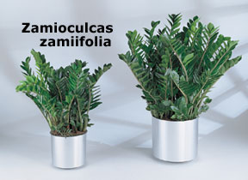  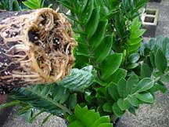  Just like all the other plants we grow our special well drained soil helps produce the best root system possible... |  | Zamioculcas zamiifolia  Foliage Plant of the Year 2002  Zamioculcas zamiifolia is commonly called the "ZZ plant" in the trade. Interior plantscapers are finding the ZZ to be an exceptional performer in any light. Especially the low light levels where few plants perform well.  This plant has very dark green, shiny foliage. In fact you would think that the plant has been shined. The ZZ carries a unique look which allows it to be used as a stand alone specimen but can also be used in mass plantings as well.  Zamioculcas zamiifolia is different in a few ways than most foliage plants. It has an underground tuber like potato that stores water. This allows the plant the ability to go for months with no water at all. The thick leaves hold water as well as the fleshy stems. Light to moderate watering every 7-14 days will keep this plant at peak health. Do not allow a ZZ to sit in water or rot may occur. Pest ae basically a non-issue with a ZZ.  I

